Odd Semester (2022)



**BINUS UNIVERSITY**

**BINUS INTERNATIONAL**

**Assignment Cover Letter**

**(Individual Work)**

|  |  |  |  |  |  |  |  |  |  |
| --- | --- | --- | --- | --- | --- | --- | --- | --- | --- |
|  | | | | |  | |  | |  |
| **Student Information**: **Surname** | | | | | **Given Names**    **Bryan** | | **Student ID Number**  **2301890983** | |  |
| 1. | | **Putra** |  | |  |
|  |  |  |
| **Course Code** | **: COMP6502** |  |  | | **Course Name** | | **: Programming Languages** | |  |
| **Class** | **: L2AC** |  |  | | **Name of Lecturer(s)** | | **:Jude Joseph Lamug Martinez** | |  |
|  |  |  |  | |  | |  | |  |
| **Major** | **: CS** |  |  | |  | |  | |  |
| **Title of Assignment**  (if any) | : Student Management System | |  |  | |  | |  | |
| **Type of Assignment**    **Submission Pattern** | **: Final Project** |  |  | |  | |  | |  |
| **Due Date** | **: 20-06-2020** |  |  | | **Submission Date** | | **: 18-06-2020** | |  |

The assignment should meet the below requirements.

1. Assignment (hard copy) is required to be submitted on clean paper, and (soft copy) as per lecturer’s instructions.
2. Soft copy assignment also requires the signed (hardcopy) submission of this form, which automatically validates the softcopy submission.
3. The above information is complete and legible.
4. Compiled pages are firmly stapled.
5. Assignment has been copied (soft copy and hard copy) for each student ahead of the submission.

# Plagiarism/Cheating

BiNus International seriously regards all forms of plagiarism, cheating and collusion as academic offenses which may result in severe penalties, including loss/drop of marks, course/class discontinuity and other possible penalties executed by the university. Please refer to the related course syllabus for further information.

# Declaration of Originality

By signing this assignment, I understand, accept and consent to BiNus International terms and policy on plagiarism. Herewith I declare that the work contained in this assignment is my own work and has not been submitted for the use of assessment in another course or class, except where this has been notified and accepted in advance.

Signature of Student: (Name of Student)

1. Bryan Putra

**“Student Management System”**

**Name : Bryan Putra**

**ID : 2301890983**

Table of Contents

**Project Specification1**

**Solution Design4**

Class Diagram**3**

**What is Happening in the code**……………………………………………………………………………………………………………….**4**

**How it works and evidence**………………………………………………………………………………………………………….……….**49**

**Problems that have been overcome**…………………………………………………………………………………………………….**61**

**Resources**……………………………………………………………………………………………………………………………………………..**61**

**Source Code……………………………………………………………………………………………………………………………………..61**

1. **Project Specification**

This project is a simple Student Management System I made using MySQL Database. At the start of making this project, I didn’t really know what to make because I am not really that creative of a person so I searched through ideas and I found an idea which is a student management system. The reason I chose to make this project is because I can learn something new from it which is the MySQL Database(Using the MySQL Workbench). I didn’t really know much about it so I just started studying the basics of it in order to start my project.

Basically this system allows you to add and manage students, courses, scores data in the database from the program. Every time we want to do something / press an add or edit or remove button, we have to get connection from the database first to connect to it using a class from downloading MySQL Connector in the Libraries in a project file in the IDE. Then to actually do the things that the buttons do, we need to prepare statements to execute queries in the database from the program. The statements are like codes with syntax according to in this case MySQL Database’s syntax(select, update, delete, insert, etc).

1. **Solution Design**

**Class Diagram**

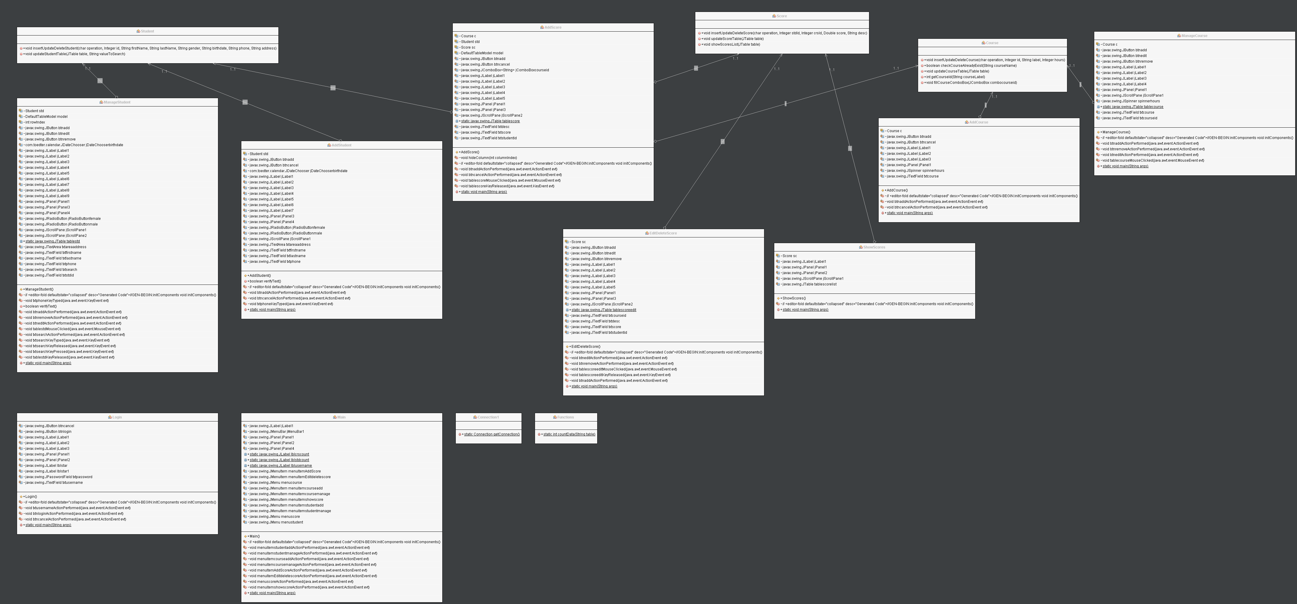

1. **What is happening in the code**

In my project, there are 14 classes which I will sort according to their categories:

1. Login - Jframe
2. Main - Jframe
3. Student
4. AddStudent - Jframe
5. ManageStudent - Jframe
6. Course
7. AddCourse - Jframe
8. ManageCourse - Jframe
9. Score
10. AddScores - Jframe
11. EditDeleteScore - Jframe
12. ShowScores - Jframe
13. Functions
14. Connection1

What I will be explaining are just the simple, main, basic explanation on what is happening when I execute these codes. The detailed explanation are all in the comments I give in the code. Also I’m not going to show the generated codes from drag and dropping and twinkling the settings because they take so much space(hundreds of lines of code each class that has JFrame) and also I will be showing only the functions / actionsperformed functions in each class, not the whole thing(excluding the class with no JFrame/GUI).

First of all I will explain the Functions and Connection1 class.

In the Functions class I stored a function called countData(String table) which takes a name of a table in my database as the parameter. I used the function to count data in a certain table in my database to update my main menu (the students and courses count)

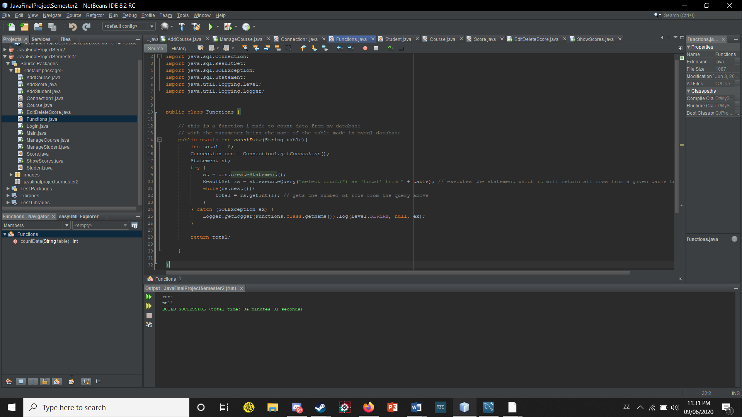

In the Connection1 class I stored a function called getConnection() which returns the Connection data type from a file called mysqlconnector.jar which I had to download it manually. This function basically does what it’s name says, to get connection from the mysql database.

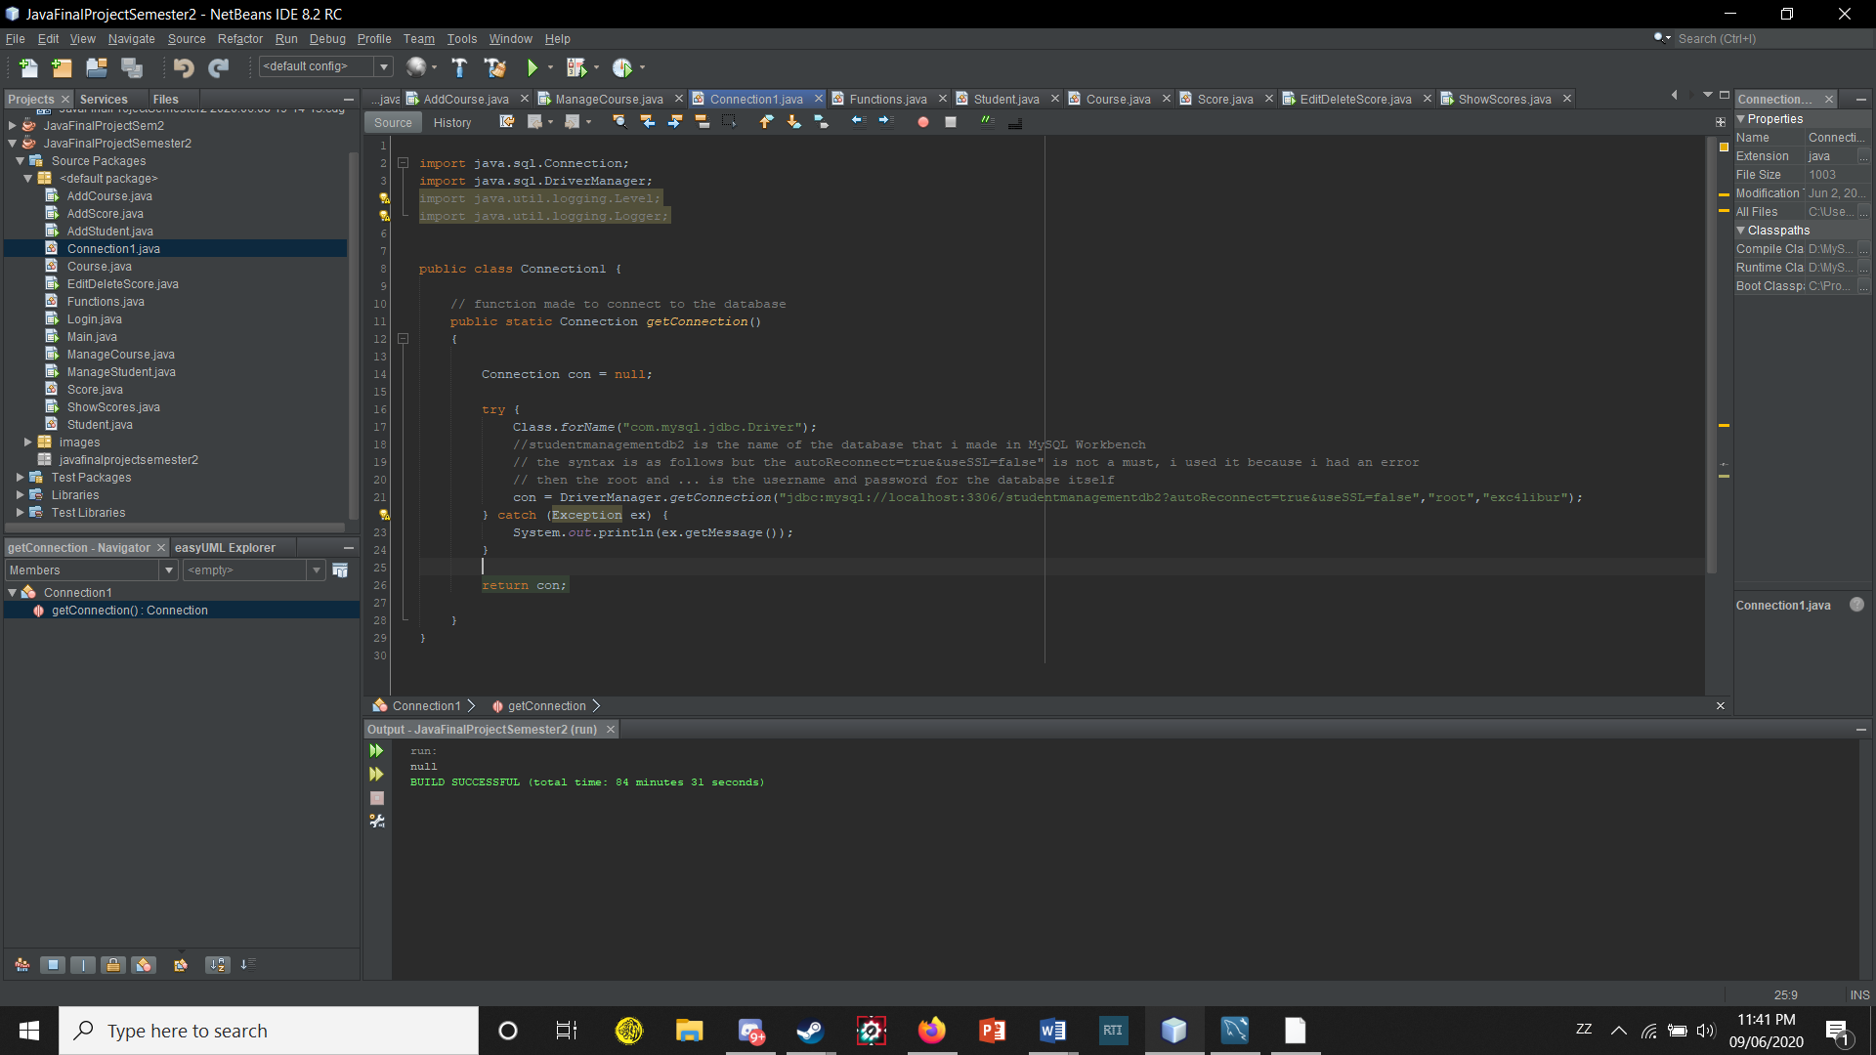

Then there is the Login and Main class.

The Login class basically is the class I used for the login window. There are auto generated codes that are generated by dragging and dropping components from the java swing GUI. The codes that I wrote are mostly written inside actions from the components like buttons and stuff. For example in the btnloginActionPerformed I wrote codes to check the textfields if they are empty or not, if they are not, then we check whether the username or password we give are present in the database or not / whether we can login with that or not. If not then the program will give us a popup message window saying that the username or password we entered is incorrect. These are just the simple basic explanation, the details are all in the comments in the code.

1. public Login() {
2. initComponents();
3. lblstar.setVisible(false); // hide the red star that indicates that the user didnt fill in a form
4. lblstar1.setVisible(false);
5. }
6. private void btnloginActionPerformed(java.awt.event.ActionEvent evt) {
7. lblstar.setVisible(false);
8. lblstar1.setVisible(false);
9. // if the user clicks on the login button with a blank username or password, they a little red star will show up next to the textfields
10. if(txtusername.getText().equals("")){
11. lblstar.setVisible(true);
12. }
13. if(String.valueOf(txtpassword.getPassword()).equals("")){
14. lblstar1.setVisible(true);
15. }
16. else{
17. // usual get connection from the database
18. Connection con = Connection1.getConnection();
19. PreparedStatement pst;
21. try {
22. //make a statement which will execute a query from the database
23. //basically this is like entering a command to the database and the database will "do" the given statement
24. //the commands or statements used for executing queries are stored inside the prepared statement object
25. //in this case it selects from user(table in the database that stores users) where username and password is ....
26. pst = con.prepareStatement("select * from user where username = ? and password = ?"); // ? are like parameters
28. pst.setString(1, txtusername.getText()); // give the parameters values which is what the user write on the textfield when executing the query
29. pst.setString(2, String.valueOf(txtpassword.getPassword()));// same as above
31. ResultSet rs = pst.executeQuery(); // if successful the executed statement will happen and ResultSet is like a table selected from the database
33. if(rs.next()){ // if the actual table does exist then it can be "next"ed
34. // what .next does is that it moves the cursor forward one row from its current position.
35. // so if they cant move forward one row from the table then it means the table was not successfully found and so it returns false that will happen in the else statement below
36. // after executing the query, open up a new window which is the main window
37. Main m = new Main();
38. m.setVisible(true);
39. m.pack();// set the window to be sized to fit the preferred size and layouts of its subcomponents.
40. m.setLocationRelativeTo(null); // set the window location popout in the center of your screen
41. Main.lblusername.setText("Welcome " + txtusername.getText() + "!"); // there is a welcome ####, this is to set the #### to be the username that you entered when you logged in
42. Main.lblstdcount.setText("Students Count = " + Integer.toString(Functions.countData("student"))); // keep track of the total students that are stored in the database
43. Main.lblcrscount.setText("Courses Count = " + Integer.toString(Functions.countData("course"))); // keep track of the total courses that are stored in the database
44. this.dispose(); // dispose the login form
45. }
46. else{
47. // show popup message if the given username or password isn't found in the database
48. JOptionPane.showMessageDialog(null, "Incorrect Username or Password", "Error Logging in", 2);
49. }
51. } catch (SQLException ex) {
52. Logger.getLogger(Login.class.getName()).log(Level.SEVERE, null, ex);
53. }
54. }
55. }
57. private void btncancelActionPerformed(java.awt.event.ActionEvent evt) {
59. System.exit(0); // exits the program
61. }

The Main class is basically our “Main menu” for this project. The Main class has all other classes that have the Jframe in the project. They all pop out when we click certain menu items. We have 3 menus which are Student, Course, Score. Each of them has menu items. Student and Course have Add and Manage which if clicked on will pop out their windows to do certain tasks. The Score has Add, Edit/Delete, and ShowScores.

The Main menu has 2 boxes and 1 label. The label being a welcoming message which I coded it to welcome a username we inputted in the login form before entering the main menu. The other 2 boxes contains information regarding how many students and courses are there in the database using a function from an another class. The code in the Main class are just to make these things pop out.

1. public Main() {
2. initComponents();
3. }
4. private void menuitemstudentaddActionPerformed(java.awt.event.ActionEvent evt) {
5. // open add student form window on clicking the add menu item on the "student" menu
6. AddStudent addstd = new AddStudent();
7. addstd.setVisible(true);
8. addstd.pack();// set the window to be sized to fit the preferred size and layouts of its subcomponents.
9. addstd.setLocationRelativeTo(null);// set window location to center
10. addstd.setDefaultCloseOperation(JFrame.DISPOSE_ON_CLOSE); // dispose on clicking the x / closing instead of exiting
11. }
13. private void menuitemstudentmanageActionPerformed(java.awt.event.ActionEvent evt) {
14. // open manage student form window on clickling the manage menu item on the "Student" menu
15. ManageStudent managestd = new ManageStudent();
16. managestd.setVisible(true);
17. managestd.pack();// set the window to be sized to fit the preferred size and layouts of its subcomponents.
18. managestd.setLocationRelativeTo(null);// set window location to center
19. managestd.setDefaultCloseOperation(JFrame.DISPOSE_ON_CLOSE);// dispose on clicking the x / closing instead of exiting
20. }
22. private void menuitemcourseaddActionPerformed(java.awt.event.ActionEvent evt) {
23. // open add course form window on clickling the add menu item on the "Course" menu
24. AddCourse addcrs = new AddCourse();
25. addcrs.setVisible(true);
26. addcrs.pack();// set the window to be sized to fit the preferred size and layouts of its subcomponents.
27. addcrs.setLocationRelativeTo(null);// set window location to center
28. addcrs.setDefaultCloseOperation(JFrame.DISPOSE_ON_CLOSE);// dispose on clicking the x / closing instead of exiting
29. }
31. private void menuitemcoursemanageActionPerformed(java.awt.event.ActionEvent evt) {
32. // open manage course form window on clickling the manage menu item on the "Course" menu
33. ManageCourse managecrs = new ManageCourse();
34. managecrs.setVisible(true);
35. managecrs.pack();// set the window to be sized to fit the preferred size and layouts of its subcomponents.
36. managecrs.setLocationRelativeTo(null);// set window location to center
37. managecrs.setDefaultCloseOperation(JFrame.DISPOSE_ON_CLOSE);// dispose on clicking the x / closing instead of exiting
38. }
40. private void menuItemAddScoreActionPerformed(java.awt.event.ActionEvent evt) {
41. // open add score form window on clickling the add menu item on the "Score" menu
42. AddScore addscore = new AddScore();
43. addscore.setVisible(true);
44. addscore.pack();// set the window to be sized to fit the preferred size and layouts of its subcomponents.
45. addscore.setLocationRelativeTo(null);// set window location to center
46. addscore.setDefaultCloseOperation(JFrame.DISPOSE_ON_CLOSE);// dispose on clicking the x / closing instead of exiting
47. }
49. private void menuItemEditdeletescoreActionPerformed(java.awt.event.ActionEvent evt) {
50. // open editdelete course form window on clickling the edit/delete menu item on the "Score" menu
51. EditDeleteScore edtdltscr = new EditDeleteScore();
52. edtdltscr.setVisible(true);
53. edtdltscr.pack();// set the window to be sized to fit the preferred size and layouts of its subcomponents.
54. edtdltscr.setLocationRelativeTo(null);// set window location to center
55. edtdltscr.setDefaultCloseOperation(JFrame.DISPOSE_ON_CLOSE);// dispose on clicking the x / closing instead of exiting
56. }
58. private void menuscoreActionPerformed(java.awt.event.ActionEvent evt) {
60. }
62. private void menuitemshowscoreActionPerformed(java.awt.event.ActionEvent evt) {
63. // open showscores form window on clicking the menu item show scores on the score menu
64. ShowScores sscore = new ShowScores();
65. sscore.setVisible(true);
66. sscore.pack();// set the window to be sized to fit the preferred size and layouts of its subcomponents.
67. sscore.setLocationRelativeTo(null);// set window location to center
68. sscore.setDefaultCloseOperation(JFrame.DISPOSE_ON_CLOSE);//

Now we have the Student, Course, and Score class. These classes will contain most of the methods that we use in the JFrame Classes for the program to be seen working.

So the first function we have in the Student class is insertUpdateDeleteStudent() with one of the parameters is a char i or u or d for insert delete update operations, the rest being the attributes the students have in the database. Basically if we give the ‘u’ char in the parameter, the function will update the database according to the given attributes. If we give ‘i’ then the function will insert data given by the user to the database, and the ‘d’ will delete a selected data selected by the user in the database from the window.

How the code works I already commented on almost every line in my code so I don’t think im gonna type it again here hehe.

There is also an another function called updateStudentTable() which takes a table and a String(value to search) as parameters. The function basically just updates/fills the student table containing data from the database. And it also updates according to what you type in the search text field in the window.

1. import java.sql.Connection;
2. import java.sql.PreparedStatement;
3. import java.sql.ResultSet;
4. import java.sql.SQLException;
5. import java.util.logging.Level;
6. import java.util.logging.Logger;
7. import javax.swing.JOptionPane;
8. import javax.swing.JTable;
9. import javax.swing.table.DefaultTableModel;

12. public class Student {
13. public void insertUpdateDeleteStudent(char operation, Integer id, String firstName,
14. String lastName, String gender, String birthdate,
15. String phone, String address)
16. {
17. // function to insert,update or delete students in the database from here
18. // the parameters are the columns that we want to manipulate which are filled with the students's attributes
19. // the operation parameter however is to determine which operation we want to do
20. Connection con = Connection1.getConnection();
21. PreparedStatement pst;
23. // u for update
24. if(operation == 'u'){
25. try {
26. // the following statement is to update the student table in the database according to the given parameters
27. pst = con.prepareStatement("UPDATE student SET first_name = ?, last_name = ?, gender = ?, birthdate = ?, phone = ?, address = ? WHERE id = ?");
28. // sets the parameters from the function to the parameters in the statement to update the database
29. pst.setString(1, firstName);
30. pst.setString(2, lastName);
31. pst.setString(3, gender);
32. pst.setString(4, birthdate);
33. pst.setString(5, phone);
34. pst.setString(6, address);
35. pst.setInt(7, id);
37. if(pst.executeUpdate() > 0){
38. // the executeUpdate() returns 0 if the statement returns nothing (fails to execute)
39. // if it is successfully done, then it returns the row count
40. // if successfully done, shows a message date updated to confirm that the task has been done
41. JOptionPane.showMessageDialog(null, "Data Updated");
42. }
44. } catch (SQLException ex) {
45. Logger.getLogger(Student.class.getName()).log(Level.SEVERE, null, ex);
46. }
47. }
48. // i for insert
49. if(operation == 'i'){
50. try {
51. // the following statement is to insert data into the table
52. // in the database, the table "student" has 6 columns which are the attributes
53. // the statement below inserts the given attributes by the user to a new made row in the database
54. pst = con.prepareStatement("insert into student(first_name, last_name, gender, birthdate, phone, address) values(?, ?, ?, ?, ?, ?)");
55. // sets the attributes according to what the user inputted
56. pst.setString(1, firstName);
57. pst.setString(2, lastName);
58. pst.setString(3, gender);
59. pst.setString(4, birthdate);
60. pst.setString(5, phone);
61. pst.setString(6, address);
63. if(pst.executeUpdate() > 0){
64. // if successfully done, shows a message date updated to confirm that the task has been done
65. JOptionPane.showMessageDialog(null, "New Student Added");
66. }
68. } catch (SQLException ex) {
69. Logger.getLogger(Student.class.getName()).log(Level.SEVERE, null, ex);
70. }
71. }
72. // d for delete
73. if(operation == 'd'){
75. int confirmation = JOptionPane.showConfirmDialog(null, "Deleting a student data will also delete their scores, Are you sure you want to continue?", "Delete Student", JOptionPane.OK_CANCEL_OPTION,0);
76. // the showconfirmdialog returns an int indicating the option selected by the user
77. // if the user selects the ok button it returns 0 if cancel i think it returns the int 2 if im not wrong
79. if(confirmation == 0){
81. try {
82. // the delete from "table" statement deletes all the rows that are in the given table
83. // but it can be specified by giving a condition by typing "where" in the query
84. // in this case, we can find a row by giving it the id of the row that we want to delete
85. pst = con.prepareStatement("delete from student where id = ?");
86. // sets the id that we want to delete which is the parameter from the function
87. pst.setInt(1, id);
89. if(pst.executeUpdate() > 0){
90. // if successfully done, shows a message date updated to confirm that the task has been done
91. JOptionPane.showMessageDialog(null, "Student Data Deleted");
92. }
94. } catch (SQLException ex) {
95. Logger.getLogger(Student.class.getName()).log(Level.SEVERE, null, ex);
96. }
98. }
100. }
102. }
104. public void updateStudentTable(JTable table, String valueToSearch){
105. // a function to update/fill the student table in the window with parameter being the name of the table's variable
106. // and value to search which is the String value that the user types in the search textfield
107. Connection con = Connection1.getConnection();
108. PreparedStatement pst;
109. try {
110. // the statement below selects from the student table where concat(concatenates) the selected columns which is first_name dll
111. // it will look like bryanputra087127231indonesia and the "like" is to check whether if the pattern of the bryanputra......... is the same as the value that we want to search
112. // basically these will give us the ability to search by typing in a textfield and the table will update according to the text that the user types in the textfield
114. pst = con.prepareStatement("select * from student where concat(first_name, last_name, phone, address)like ?");
115. pst.setString(1, "%" + valueToSearch + "%"); // the %valuetosearch% finds any values that have "value to search" in any position
116. ResultSet rs = pst.executeQuery();
117. DefaultTableModel model = (DefaultTableModel)table.getModel(); // make a new table model
119. Object [] row; // making an empty row
121. while(rs.next()){
122. // iterating through the contents/rows of the resultset (which is the selected table in the database)
123. row = new Object[7]; // make a row with 7 columns which we will fill with attributes from the resultset
124. row[0] = rs.getInt(1);
125. row[1] = rs.getString(2);
126. row[2] = rs.getString(3);
127. row[3] = rs.getString(4);
128. row[4] = rs.getString(5);
129. row[5] = rs.getString(6);
130. row[6] = rs.getString(7);
132. model.addRow(row); // give the table model a row every iteration
134. }
136. } catch (SQLException ex) {
137. Logger.getLogger(Student.class.getName()).log(Level.SEVERE, null, ex);
138. }
140. }
142. }

The second class is the Course class containing functions used for the Add/Manage Course class(JFrame). The first 2 functions are basically very similar if not the same as from the Student class which are insertUpdateDeleteCourse() and updateCourseTable()

The only difference being the parameters given and the updatecoursetable doesn’t have a String value to search because I didn’t give the course window a search feature.

But in this class we have other functions as well which are checkCourseAlreadyExist() that takes a String course name as its parameter. Basically what it does is what the name of the functions says which is to check whether the course that the user entered to add already exists in the database or not. The function returns true if the course entered by the user already exists in the database, returns false otherwise.

The next function is getCourseId() with String course name being the parameter. Basically we give it a course name and the function will return an id that matches the given course name in the database.

The last function is fillCourseComboBox() with the parameter being a combobox from the window. This function is to give items to the combo box and those items being data from the database.

1. import java.sql.Connection;
2. import java.sql.PreparedStatement;
3. import java.sql.ResultSet;
4. import java.sql.SQLException;
5. import java.util.logging.Level;
6. import java.util.logging.Logger;
7. import javax.swing.JComboBox;
8. import javax.swing.JOptionPane;
9. import javax.swing.JTable;
10. import javax.swing.table.DefaultTableModel;
12. public class Course {
13. public void insertUpdateDeleteCourse(char operation, Integer id, String label, Integer hours)
14. {
15. // function to insert,update or delete courses in the database from here
16. // the parameters are the columns that we want to manipulate which are filled with the courses's attributes
17. // the operation parameter however is to determine which operation we want to do
18. Connection con = Connection1.getConnection();
19. PreparedStatement pst;
21. // i for insert
22. if(operation == 'i'){
23. try {
24. // the following statement is to insert data into the table
25. // in the database, the table "courses" has 3 columns which are the attributes
26. // the statement below inserts the given attributes by the user to a new made row in the database
27. pst = con.prepareStatement("insert into course(label, hours_number) values(?, ?)");
28. // sets the attributes according to what the user inputted
29. pst.setString(1, label);
30. pst.setInt(2, hours);
32. if(pst.executeUpdate() > 0){
33. // if successfully done, shows a message date updated to confirm that the task has been done
34. JOptionPane.showMessageDialog(null, "New Course Added");
35. }
37. } catch (SQLException ex) {
38. Logger.getLogger(Student.class.getName()).log(Level.SEVERE, null, ex);
39. }
40. }
41. // u for update
42. if(operation == 'u'){
43. try {
44. // the following statement is to update the course table in the database according to the given parameters
45. pst = con.prepareStatement("UPDATE course SET label = ?, hours_number = ? WHERE id = ?");
46. // sets the parameters from the function to the parameters in the statement to update the database
47. pst.setString(1, label);
48. pst.setInt(2, hours);
49. pst.setInt(3, id);
51. if(pst.executeUpdate() > 0){
52. // the executeUpdate() returns 0 if the statement returns nothing (fails to execute)
53. // if it is successfully done, then it returns the row count
54. // if successfully done, shows a message date updated to confirm that the task has been done
55. JOptionPane.showMessageDialog(null, "Data Updated");
56. }
58. } catch (SQLException ex) {
59. Logger.getLogger(Student.class.getName()).log(Level.SEVERE, null, ex);
60. }
61. }
63. // // d for delete
64. if(operation == 'd'){
65. // the showconfirmdialog returns an int indicating the option selected by the user
66. // if the user selects the ok button it returns 0 if cancel i think it returns the int 2 if im not wrong
67. int confirmation = JOptionPane.showConfirmDialog(null, "Deleting a course data will also delete their scores, Are you sure you want to continue?", "Delete Course", JOptionPane.OK_CANCEL_OPTION,0);
69. if(confirmation == 0){
71. try {
72. // the delete from "table" statement deletes all the rows that are in the given table
73. // but it can be specified by giving a condition by typing "where" in the query
74. // in this case, we can find a row by giving it the id of the row that we want to delete
75. pst = con.prepareStatement("delete from course where id = ?");
76. // sets the id that we want to delete which is the parameter from the function
77. pst.setInt(1, id);
79. if(pst.executeUpdate() > 0){
80. // if successfully done, shows a message date updated to confirm that the task has been done
81. JOptionPane.showMessageDialog(null, "Course Deleted");
82. }
84. } catch (SQLException ex) {
85. Logger.getLogger(Student.class.getName()).log(Level.SEVERE, null, ex);
86. }
88. }
90. }
92. }
94. public boolean checkCourseAlreadyExist(String courseName){
95. // this is a function to check whether a course is already registered in the database so that there are no doubles
96. // the parameter for this function is the coursename we want to check
97. boolean isPresent = false;
98. Connection con = Connection1.getConnection();
99. PreparedStatement pst;
100. try {
101. // checks from the database if the given course name is already present in the database or not if yes returns true if not returns false
102. pst = con.prepareStatement("select * from course where label = ?");
103. pst.setString(1, courseName);
104. ResultSet rs = pst.executeQuery();
106. // if the query is successfully executed which means the result set would exist
107. // meaning if the course we want to check is already in the result set / table and we can move through the row by using .next()
108. // then we set it to true
109. if(rs.next()){
110. isPresent = true;
111. }
113. } catch (SQLException ex) {
114. Logger.getLogger(Student.class.getName()).log(Level.SEVERE, null, ex);
115. }
116. // returns true or false within the isPresent variable
117. return isPresent;
118. }
120. public void updateCourseTable(JTable table){
121. // function to update the course table
122. // similar to the updateStudentTable function i made but this doesn't have the search feature in it
123. Connection con = Connection1.getConnection();
124. PreparedStatement pst;
125. try {
126. // select elements from course table in the database
127. // stores them in the ResultSet
128. pst = con.prepareStatement("select * from course");
129. ResultSet rs = pst.executeQuery();
130. // make new model for the table in the window
131. DefaultTableModel model = (DefaultTableModel)table.getModel();
133. Object [] row;
135. while(rs.next()){
136. // iterating through the contents/rows of the resultset (which is the selected table in the database)
137. row = new Object[3]; // make a row with 3 columns which we will fill with attributes from the resultset
138. row[0] = rs.getInt(1);
139. row[1] = rs.getString(2);
140. row[2] = rs.getInt(3);
142. model.addRow(row); // give the table model a row every iteration
144. }
146. } catch (SQLException ex) {
147. Logger.getLogger(Student.class.getName()).log(Level.SEVERE, null, ex);
148. }
150. }
151. public int getCourseId(String courseLabel){
153. int courseId = 0;
155. Connection con = Connection1.getConnection();
156. PreparedStatement pst;
157. try {
158. pst = con.prepareStatement("select * from course where label = ?");
159. pst.setString(1, courseLabel);
160. ResultSet rs = pst.executeQuery();
162. if(rs.next()){
163. courseId = rs.getInt("Id");
164. }
166. } catch (SQLException ex) {
167. Logger.getLogger(Student.class.getName()).log(Level.SEVERE, null, ex);
168. }
170. return courseId;
171. }
173. public void fillCourseComboBox(JComboBox combocourseid){
174. // a function to add items into the combobox which contains the names of the courses
175. Connection con = Connection1.getConnection();
176. PreparedStatement pst;
177. try {
178. // select elements from the course tabel
179. // puts in the ResultSet
180. pst = con.prepareStatement("select * from course");
181. ResultSet rs = pst.executeQuery();
183. while(rs.next()){
184. // iterates through the elements in the resultset
185. // we add items to the combobox with 2 being the column index in the table/result set which in my database is the label/name of the course
186. combocourseid.addItem(rs.getString(2));
188. }
190. } catch (SQLException ex) {
191. Logger.getLogger(Student.class.getName()).log(Level.SEVERE, null, ex);
192. }
194. }
195. }

The last class is the Score class. The 2 functions(insertupdatedeletedata and updateTable) are also like the functions from the Course class. The other function which is the showScoresList() takes a table(JTable) as a parameter. This function is used for the last JFrame class I made which is to show all the scores have been made before by first and last name and the course name to make it easier for the user to view it.

1. import java.sql.Connection;
2. import java.sql.PreparedStatement;
3. import java.sql.ResultSet;
4. import java.sql.SQLException;
5. import java.util.logging.Level;
6. import java.util.logging.Logger;
7. import javax.swing.JOptionPane;
8. import javax.swing.JTable;
9. import javax.swing.table.DefaultTableModel;
11. public class Score {
13. public void insertUpdateDeleteScore(char operation, Integer stdId, Integer crsId, Double score, String desc)
14. {
16. Connection con = Connection1.getConnection();
17. PreparedStatement pst;
19. // i for insert
20. if(operation == 'i'){
21. try {
22. // the following statement is to insert data into the table
23. // in the database, the table "scores" has 4 columns which are the attributes
24. // the statement below inserts the given attributes by the user to a new made row in the database
25. pst = con.prepareStatement("insert into score(student_id, course_id, student_score, description) values(?, ?, ?, ?)");
26. // sets the attributes according to what the user inputted
27. pst.setInt(1, stdId);
28. pst.setInt(2, crsId);
29. pst.setDouble(3, score);
30. pst.setString(4, desc);
32. if(pst.executeUpdate() > 0){
33. // if successfully done, shows a message date updated to confirm that the task has been done
34. JOptionPane.showMessageDialog(null, "Score Added");
35. }
37. } catch (SQLException ex) {
38. Logger.getLogger(Student.class.getName()).log(Level.SEVERE, null, ex);
39. }
40. }
42. // u for update
43. if(operation == 'u'){
44. try {
45. // the following statement is to update the score table in the database according to the given parameters
46. pst = con.prepareStatement("UPDATE score SET student_score = ?, description = ? WHERE student_id = ? and course_id = ?");
47. // sets the parameters from the function to the parameters in the statement to update the database
48. pst.setDouble(1, score);
49. pst.setString(2, desc);
50. pst.setInt(3, stdId);
51. pst.setInt(4, crsId);
53. if(pst.executeUpdate() > 0){
54. // the executeUpdate() returns 0 if the statement returns nothing (fails to execute)
55. // if it is successfully done, then it returns the row count
56. // if successfully done, shows a message date updated to confirm that the task has been done
57. JOptionPane.showMessageDialog(null, "Data Updated");
58. }
60. } catch (SQLException ex) {
61. Logger.getLogger(Student.class.getName()).log(Level.SEVERE, null, ex);
62. }
63. }
64. // d for delete
65. if(operation == 'd'){
66. try {
67. // the delete from "table" statement deletes all the rows that are in the given table
68. // but it can be specified by giving a condition by typing "where" in the query
69. // in this case, we can find a row by giving it the id of the row that we want to delete
70. pst = con.prepareStatement("delete from score where student_id = ? and course_id = ?");
71. pst.setInt(1, stdId);
72. pst.setInt(2, crsId);
73. // sets the ids that we want to delete which is the parameter from the function
75. if(pst.executeUpdate() > 0){
76. JOptionPane.showMessageDialog(null, "Score Data Deleted");
77. }
79. } catch (SQLException ex) {
80. Logger.getLogger(Student.class.getName()).log(Level.SEVERE, null, ex);
81. }
82. }
83. }
85. public void updateScoreTable(JTable table){
87. Connection con = Connection1.getConnection();
88. PreparedStatement pst;
89. try {
90. // select elements from course table in the database
91. // stores them in the ResultSet
92. pst = con.prepareStatement("select * from score");
93. ResultSet rs = pst.executeQuery();
94. // make new model for the table in the window
95. DefaultTableModel model = (DefaultTableModel)table.getModel();
97. Object [] row;
99. while(rs.next()){
100. // iterating through the contents/rows of the resultset (which is the selected table in the database)
101. row = new Object[4];// make a row with 4 columns which we will fill with attributes from the resultset
102. row[0] = rs.getInt(1);
103. row[1] = rs.getInt(2);
104. row[2] = rs.getDouble(3);
105. row[3] = rs.getString(4);
107. model.addRow(row);// give the table model a row every iteration
109. }
111. } catch (SQLException ex) {
112. Logger.getLogger(Student.class.getName()).log(Level.SEVERE, null, ex);
113. }
115. }
117. public void showScoresList(JTable table){
119. Connection con = Connection1.getConnection();
120. PreparedStatement pst;
121. try {
122. // the INNER JOIN matches each row in one table with every row in other tables and allows you to query rows that contain columns from both tables.
123. // the table will display student id, first and last name(which are from the student table in the database), course name ( i named in label in the course table)
124. // , and score
125. pst = con.prepareStatement("select student_id, first_name, last_name, label, student_score from score\n" +
126. "inner join student as stab on stab.id = student_id\n" +
127. "inner join course as ctab on ctab.id = course_id");
128. ResultSet rs = pst.executeQuery();
129. DefaultTableModel model = (DefaultTableModel)table.getModel();
131. Object [] row;
133. while(rs.next()){
134. // iterating through the contents/rows of the resultset (which is the selected table in the database)
135. row = new Object[5];// make a row with 3 columns which we will fill with attributes from the resultset
136. row[0] = rs.getInt(1);
137. row[1] = rs.getString(2);
138. row[2] = rs.getString(3);
139. row[3] = rs.getString(4);
140. row[4] = rs.getDouble(5);
142. model.addRow(row); // give the table model a row every iteration
144. }
146. } catch (SQLException ex) {
147. Logger.getLogger(Student.class.getName()).log(Level.SEVERE, null, ex);
148. }
150. }
152. }

The next Classes are the AddStudent, AddScore, and AddCourse classes which are used for the windows for adding students, courses, and scores.

First is the AddStudent class. There is a boolean function called verifyText() to check whether all the text fields in the form/window are filled correctly or not. Returns true if filled correctly, returns false otherwise. Also pops out error messages if filled incorrectly.

The other functions are based on the GUI components like buttons.

First one is the on the buttonactionperformed ( its like when the button is pressed then blablablabal happens). So we store all the things that are in the fields/forms into variables so we can twinkle with them. Then using the verifytext function, we check if it is filled correctly we add those data given by the user to the database.

Function for the cancel button is to dispose the window.

There is also on key typed on the textfield for entering a phone number, I made it so we can only type numbers on the field, so if we type letters, the letters will just be consumed and not present in the textfield.

1. Student std;
2. public AddStudent() {
3. initComponents();
4. // the button group is used for the jradio button male and female
5. // it is to make like a group of the jradio buttons so that only one of the buttons in the group can be selected
6. ButtonGroup bg = new ButtonGroup();
7. bg.add(jRadioButtonmale);
8. bg.add(jRadioButtonfemale);
9. jRadioButtonmale.setSelected(true);
10. }
12. public boolean verifyText(){
13. // a function to check if all of the textfields/ form is filled correctly
14. // returns false if something is missing, returns true otherwise
15. if(txtfirstname.getText().equals("") || txtlastname.getText().equals("") ||
16. txtphone.getText().equals("") || txtareaaddress.getText().equals("") ||
17. jDateChooserbirthdate.getDate() == null){
19. JOptionPane.showMessageDialog(null, "Please fill in ALL of the given form");
20. return false;
21. }
22. // this is to make so that we can't choose a date higher than the current date in our world
23. else if(jDateChooserbirthdate.getDate().compareTo(new Date()) > 0){
25. JOptionPane.showMessageDialog(null, "Invalid date inputted");
26. return false;
27. }
28. else{
29. return true;
30. }
31. }
33. private void btnaddActionPerformed(java.awt.event.ActionEvent evt) {
34. //stores what the user typed or inputted in the form to variables except the date because it works differently
35. String firstName = txtfirstname.getText();
36. String lastName = txtlastname.getText();
37. String phone = txtphone.getText();
38. String address = txtareaaddress.getText();
39. String gender = "Male";
40. if(jRadioButtonfemale.isSelected()){
41. // the default gender in the variable is set to male, if the female is selected, the gender whill change values to "female"
42. gender = "Female";
43. }
45. if(verifyText()){
46. // if all are filled correctly
47. // stores the date given from the form into a variable
48. // using simpledateformat class to format a date given
49. SimpleDateFormat dateFormat = new SimpleDateFormat("yyyy--MM--dd");
50. String birthdate = dateFormat.format(jDateChooserbirthdate.getDate());
52. Student std = new Student();
54. // using the a function from the Student class, we inserted a student with datas from the texts the user gave with the id being auto incremented in the database
55. std.insertUpdateDeleteStudent('i', null, firstName, lastName, gender, birthdate, phone, address);
57. // this just updates how many students are currently in the database right now using the countData function from the Functions class
58. Main.lblstdcount.setText("Students Count = " + Integer.toString(Functions.countData("student")));
60. try{
61. // this is to update the table from the ManageStudent window whenever we add a student in the AddStudent form
62. // because i made the addStudent form being accessible in the ManageStudent form so i have to update the manageStudent table
63. // whenever we add students from the manage student window using the function from student class
64. ManageStudent.tablestd.setModel(new DefaultTableModel(null, new Object[]{"Id", "First Name", "Last Name", "Gender", "Birthdate", "Phone", "Address"}));
65. std.updateStudentTable(ManageStudent.tablestd, "");
66. }
68. catch(Exception ex){
69. // if the manage student form is not open
70. System.out.println(ex.getMessage());
71. }
73. }

76. }
78. private void btncancelActionPerformed(java.awt.event.ActionEvent evt) {
79. this.dispose(); // dispose the menu which is the addstudent menu
80. }
82. private void txtphoneKeyTyped(java.awt.event.KeyEvent evt) {
83. // allow only numbers
84. if(!Character.isDigit(evt.getKeyChar())){ // if the characters that we are typing are not digits they wont show up
85. evt.consume(); // consumes the event so that it will not be processed
86. }
87. }
89. /**
90. * @param args the command line arguments
91. */

In the AddCourse Class, we only have functions onbtnaddActionPerformed and onbtncancelPerformed. On the add button, when we click it, first it checks if the course form is filled or not, if not pops out message to please fill the form, if yes then first it checks the course given by the user whether it already exists in the database or not using the function from the Course class. If it already exists, pops out a message saying it already exists in the database. If it is new, stores the given data from user to variables, so that they can be put as parameters for the insertUpdateDeleteCourse function from the Course class to insert the data into the database. After that, we update the data count on the main menu and also update the table in the ManageCourse class which I will get into later on. On the button cancel as usual is just to dispose of the window.

1. Course c = new Course();
2. public AddCourse() {
3. initComponents();
4. }
5. private void btnaddActionPerformed(java.awt.event.ActionEvent evt) {
6. // the function checkCourseAlreadyExist in the Course class returns true if the course already exists in the database
7. // with the parameter being the given course by the user
8. // so if there the course given from the user is new
9. if(txtcourse.getText().equals("")){
10. JOptionPane.showMessageDialog(null, "Please fill the course form");
11. }
12. else{
13. if(!c.checkCourseAlreadyExist(txtcourse.getText())){
14. // store the given data from user to variables
15. String label = txtcourse.getText();
16. int hours = Integer.valueOf(spinnerhours.getValue().toString());
17. // function from Course class to insert/update/dll
18. // in this case we want to add which is inserting
19. // and also updates the course count afterwards
20. c.insertUpdateDeleteCourse('i', null, label, hours);
21. Main.lblcrscount.setText("Courses Count = " + Integer.toString(Functions.countData("course")));
23. try{
24. // this is to update the table in the ManageCourse Window
25. ManageCourse.tablecourse.setModel(new DefaultTableModel(null, new Object[]{"Id", "Label", "Hours"}));
26. c.updateCourseTable(ManageCourse.tablecourse);
27. } catch(Exception ex){
28. System.out.println(ex.getMessage());
29. }
31. }
33. else{
34. JOptionPane.showMessageDialog(null, "Course Already Exists");
35. }
36. }


40. }
42. private void btncancelActionPerformed(java.awt.event.ActionEvent evt) {
43. this.dispose();
44. }
46. /**
47. * @param args the command line arguments
48. */

The last class is the AddScore class. In this class, we have objects from 3 classes to get their functions used. At the start of the program I fill the combobox (course) with data from the database using a function from the course class (fillCourseComboBox) and updateStudentTable to immediately update the table so that when we open up the window the data on the table are set and ready to check. I also hid columns since I had the table copied from the ManageStudent class I think using a function I made to hide columns because in this window we didn’t really need the other data from the ManageStudent table.

So there are 3 methods we can observe which are btnaddActionPerformed which is on button add clicked, btncancelActionPerformed (on button cancel clicked), and tableScoreMouseClicked(when we click a row or something on a table). The button add basically inserts given data from the user and stores it into the database and also updates the table from the EditDeleteScore if we actually open the AddScore form from the EditDeleteScore form. Button cancel as usual just disposes the window. Lastly the table clicked is when we click on a row on the table, we get the id from the table and fill the student id text field with it.

1. Course c = new Course();
2. Student std = new Student();
3. Score sc = new Score();
4. DefaultTableModel model;
5. public AddScore() {
6. initComponents();
7. c.fillCourseComboBox(jComboBoxcourseid); // fill the course combobox with data from the database using a function from Course class
8. std.updateStudentTable(tablescore, ""); // update the table on the window
10. hideColumn(6); // this table is actually copy pasted from an another class
11. hideColumn(5); // so i just hid the unnecessary columns using a function i made below
12. hideColumn(4);
13. hideColumn(3);
15. model = (DefaultTableModel)tablescore.getModel(); // get model table
16. tablescore.setRowHeight(30); // twinkle with table appearance
17. tablescore.setShowGrid(true);
18. tablescore.setGridColor(Color.ORANGE);
19. tablescore.setSelectionBackground(Color.BLACK);
20. }
22. private void hideColumn(int columnIndex){
23. //function to hide columns on a table
24. TableColumn col = tablescore.getColumnModel().getColumn(columnIndex); // store a column from the score table in a variable
25. // with the parameter of the function being the index of the column
26. // then set the max/min/preferred width to 0 for it to be invisible
27. col.setMaxWidth(0);
28. col.setMinWidth(0);
29. col.setPreferredWidth(0);
30. }
31. private void btnaddActionPerformed(java.awt.event.ActionEvent evt) {
32. // stores what the user typed or inputted in the form to variables
33. int stdId = Integer.valueOf(txtstudentid.getText());
34. int crsId = c.getCourseId(jComboBoxcourseid.getSelectedItem().toString());
35. double scr = Double.valueOf(txtscore.getText());
37. // using the a function from the Score class, we inserted a score belonging to a certain student with a certain course with description
38. sc.insertUpdateDeleteScore('i', stdId, crsId, scr, txtdesc.getText());
40. try{
41. // this is to update the table from the EditDeleteScore window whenever we add a score in the AddScore form
42. // because i made the AddScore form being accessible in the EditDeleteScore form so i have to update the editscore table
43. // whenever we add scores from the EditDeleteScore window using the function from Score class
44. EditDeleteScore.tablescoreedit.setModel(new DefaultTableModel(null, new Object []{"Student Id", "Course Id", "Score", "Description"}));
45. sc.updateScoreTable(EditDeleteScore.tablescoreedit);
46. } catch(Exception ex){
47. // if the addscore form is not opened from the edit/delete score form
48. System.out.println(ex.getMessage());
49. }
51. }
53. private void btncancelActionPerformed(java.awt.event.ActionEvent evt) {
54. this.dispose();
56. }
58. private void tablescoreMouseClicked(java.awt.event.MouseEvent evt) {
59. // if i click on a row on the table
60. // the student id textfield will fill itself with the data selected from the row
61. int rowIndex = tablescore.getSelectedRow();
62. txtstudentid.setText(tablescore.getValueAt(rowIndex, 0).toString());
64. }

The final set of Classes are ManageStudent, ManageCourse, Edit/DeleteScore, ShowScores.

The ManageStudent class first updates student table and add the jRadioButtons to a ButtonGroup(class) object to make it so that only one of them are able to be selected.

We also have a function verifyText() which is almost the same as the previous verifyText function because it’s purpose is the same to check the contents in the textfield given by the user. On the txtPhoneKeyTyped() I fill in a condition so that we can’t type any alphabets on the phone text field only numbers. On the button add, it just does what the AddStudent does which is popping out the window for adding students which is why I update the student table in the AddStudent class (the student table I mentioned is in the ManageStudent window).

On the remove button I had to execute a query directly from the my sql workbench so that i can make it so that when we delete a student, we also need to delete their scores. In order to do that, I put the information in the comments on the code. Basically the remove button first will take the student id we want to delete then deletes it in the database. Also updates the student table and the student count(on the main menu). Then sets every textfield to blank.

There is also an edit button which is to edit a certain student information on the table.

After all the forms are filled, it checks if there is nothing wrong with the given information with a function then updates the database and also updates the table.

On the table mouse clicked, I coded it so that when we click on a certain row in the table, the textfields/forms on the window will be filled with those data on the row of the table to make it more convenient for the user to edit information/data.

On searchkeyreleased I used the updateStudentTable() function and give the String valueToSearch parameter the text that we get from the search textfield so that it updates the table as we type something on the search textfield (it’s just a search feature for the table so that we can search through students).

And lastly there is the tablekeyreleased to make it if we press the arrow down up key button on our keyboard on the table, the forms are filled with the current data that your on when pressing the up down arrow keys while on the table.

1. Student std = new Student();
2. DefaultTableModel model;
4. public ManageStudent() {
5. initComponents();
6. std.updateStudentTable(tablestd, ""); // at the start of popping the window, updates the student table using function from the Student class
7. ButtonGroup bg = new ButtonGroup(); // make new button group the reason to make this is in the AddStudent class in a comment i wrote
8. bg.add(jRadioButtonmale);
9. bg.add(jRadioButtonfemale);
10. model = (DefaultTableModel)tablestd.getModel(); // new student table model
11. // just twinkling with the table's appearance
12. tablestd.setRowHeight(30);
13. tablestd.setShowGrid(true);
14. tablestd.setGridColor(Color.BLUE);
15. tablestd.setSelectionBackground(Color.BLACK);
16. }
18. private void txtphoneKeyTyped(java.awt.event.KeyEvent evt) {
19. // allow only numbers
20. if(!Character.isDigit(evt.getKeyChar())){ // if the characters that we are typing are not digits they wont show up
21. evt.consume(); // consumes the event so that it will not be processed
22. }
23. }
25. public boolean verifyText(){
27. // the same function in the addStudent class
28. if(txtfirstname.getText().equals("") || txtlastname.getText().equals("") ||
29. txtphone.getText().equals("") || txtareaaddress.getText().equals("") ||
30. txtstdid.getText().equals("") || jDateChooserbirthdate.getDate() == null){
32. JOptionPane.showMessageDialog(null, "Please fill in ALL of the given form");
33. return false;
34. }
35. // can only choose a date higher than the current date in our world
36. else if(jDateChooserbirthdate.getDate().compareTo(new Date()) > 0){
38. JOptionPane.showMessageDialog(null, "Invalid date inputted");
39. return false;
40. }
41. else{
42. return true;
43. }
44. }
46. private void btnaddActionPerformed(java.awt.event.ActionEvent evt) {
47. // if we click the add button on the screen, pops out a new AddStudent window too add students
48. AddStudent addstd = new AddStudent();
49. addstd.setVisible(true);
50. addstd.pack();
51. addstd.setLocationRelativeTo(null);
52. addstd.setDefaultCloseOperation(JFrame.DISPOSE_ON_CLOSE);
53. }
55. private void btnremoveActionPerformed(java.awt.event.ActionEvent evt) {
56. // removing a student means that all the scores that the student has will also be deleted
57. // so i added a constraint to the score table to do this(done in the database) by executing a query in the below statement
58. // basically what the below statement does is if i delete a student in the "student" table in the database, then the scores that the student has will also be deleted
59. // what happens is that the score table which has student_id column will be altered or updated if any of the student id from the student table is deleted
60. // hence it also deletes a student id in the score table deleting a row of the score table as well
61. // ALTER TABLE score
62. // add CONSTRAINT fk_score_student
63. // FOREIGN KEY (student_id) // student_id from child table which is the score table
64. // REFERENCES student(id) // with the reference being the parent table with a given column, in this case its the student table since we are deleting a student and his/her id
65. // on DELETE CASCADE
66. // constraint -> foreign key + on deletee cascade
68. if(txtstdid.getText().equals("")){
69. // if there are no student id in the textfield, gives error message that no student has been selected to be deleted
70. JOptionPane.showMessageDialog(null, "No Student Selected");
71. }
72. else{
73. // if there is a student selected,
74. // store the student id selected in a variable
75. int id = Integer.valueOf(txtstdid.getText());
76. // delete a student with the id using function from the Student class
77. std.insertUpdateDeleteStudent('d', id, null, null, null, null, null, null);
78. // updates the table
79. std.updateStudentTable(tablestd, "");
81. // making a new model table for me is to fix a bug i had
82. // using my updatestudenttable function, it just + the newly updated table without deleting the unupdated table
83. // so what i did is just to reset the table using a new model everytime we update a table
84. tablestd.setModel(new DefaultTableModel(null, new Object[]{"Id","First Name","Last Name","Gender","Birthdate","Phone","Address"}));
85. std.updateStudentTable(tablestd, txtsearch.getText());
87. // updates the student count on the main menu upon deleting a student
88. Main.lblstdcount.setText("Students Count = " + Integer.toString(Functions.countData("student")));
90. // blanks all the textfield in the form
91. txtfirstname.setText("");
92. txtlastname.setText("");
93. txtphone.setText("");
94. txtareaaddress.setText("");
95. jRadioButtonmale.setSelected(false);
96. jRadioButtonfemale.setSelected(false);
97. jDateChooserbirthdate.setDate(null);
98. }
100. }
102. private void btneditActionPerformed(java.awt.event.ActionEvent evt) {
103. // store the texts typed by the user on the textfields to variables
104. int id = Integer.valueOf(txtstdid.getText());
105. String firstName = txtfirstname.getText();
106. String lastName = txtlastname.getText();
107. String phone = txtphone.getText();
108. String address = txtareaaddress.getText();
109. String gender = "Male";
110. if(jRadioButtonfemale.isSelected()){
111. gender = "Female";
112. }
114. if(verifyText()){
116. // basically i did the same thing on the AddStudent class but the function for inserupdate dll i set it to update
117. SimpleDateFormat dateFormat = new SimpleDateFormat("yyyy--MM--dd");
118. String birthdate = dateFormat.format(jDateChooserbirthdate.getDate());
120. Student std = new Student();
121. std.insertUpdateDeleteStudent('u', id, firstName, lastName, gender, birthdate, phone, address);
123. ManageStudent.tablestd.setModel(new DefaultTableModel(null, new Object[]{"Id", "First Name", "Last Name", "Gender", "Birthdate", "Phone", "Address"}));
124. std.updateStudentTable(ManageStudent.tablestd, "");
125. }
126. }
128. int rowIndex;
129. private void tablestdMouseClicked(java.awt.event.MouseEvent evt) {
130. // what im doing here is if the user click on one of the rows on the table, then the textfields or forms are then filled with the data that just got clicked
131. // so that they can edit the data that is in the table easily
132. // store the index of the selected row in a variable
133. rowIndex = tablestd.getSelectedRow();
135. model = (DefaultTableModel)tablestd.getModel();
137. jRadioButtonfemale.setSelected(false);
138. jRadioButtonmale.setSelected(false);
140. if(model.getValueAt(rowIndex, 3).toString().equals("Male")){
141. // if tablemodel get value at (row index, column) which 3 is the gender column == male .....
142. jRadioButtonmale.setSelected(true);
143. }
144. else{
145. jRadioButtonfemale.setSelected(true);
146. }
148. // set the textfields with values from the student table
149. txtstdid.setText(model.getValueAt(rowIndex, 0).toString());
150. txtfirstname.setText(model.getValueAt(rowIndex, 1).toString());
151. txtlastname.setText(model.getValueAt(rowIndex, 2).toString());
152. txtphone.setText(model.getValueAt(rowIndex, 5).toString());
153. txtareaaddress.setText(model.getValueAt(rowIndex, 6).toString());
155. Date birthdate;
156. try {
157. // this is how we get the date values from table to the text
158. birthdate = new SimpleDateFormat("yyyy-MM-dd").parse(model.getValueAt(rowIndex, 4).toString());
159. jDateChooserbirthdate.setDate(birthdate);
160. } catch (ParseException ex) {
161. Logger.getLogger(ManageStudent.class.getName()).log(Level.SEVERE, null, ex);
162. }
163. }
165. private void txtsearchActionPerformed(java.awt.event.ActionEvent evt) {
167. }
169. private void txtsearchKeyTyped(java.awt.event.KeyEvent evt) {
171. }
173. private void txtsearchKeyReleased(java.awt.event.KeyEvent evt) {
174. // using the updateStudentTable function i made a search feature in the window
175. // this happens when we type something in the search textfield
176. tablestd.setModel(new DefaultTableModel(null, new Object[]{"Id","First Name","Last Name","Gender","Birthdate","Phone","Address"}));
177. std.updateStudentTable(tablestd, txtsearch.getText());
178. }
180. private void txtsearchKeyPressed(java.awt.event.KeyEvent evt) {
182. }
184. private void tablestdKeyReleased(java.awt.event.KeyEvent evt) {
186. // in the table(window) we can press the up down arrow keys when selecting the table to go up or down through the data
187. // this is to make when we are going up or down through the data we also set the form or textfields according to the current data that we are on when we are going through them
188. // its more clear in the video demonstration
189. if(evt.getKeyCode() == KeyEvent.VK_UP || evt.getKeyCode() == KeyEvent.VK_DOWN){
191. // basically this is the same thing as the table mouse clicked
192. // because how it works is the same
193. rowIndex = tablestd.getSelectedRow();
194. txtstdid.setText(model.getValueAt(rowIndex, 0).toString());
195. txtfirstname.setText(model.getValueAt(rowIndex, 1).toString());
196. txtlastname.setText(model.getValueAt(rowIndex, 2).toString());
197. txtphone.setText(model.getValueAt(rowIndex, 5).toString());
198. txtareaaddress.setText(model.getValueAt(rowIndex, 6).toString());
200. if(model.getValueAt(rowIndex, 3).toString().equals("Male")){
201. jRadioButtonmale.setSelected(true);
202. jRadioButtonfemale.setSelected(false);
203. }
204. else{
205. jRadioButtonfemale.setSelected(true);
206. jRadioButtonmale.setSelected(false);
207. }
208. Date birthdate;
209. try {
210. birthdate = new SimpleDateFormat("yyyy-MM-dd").parse(model.getValueAt(rowIndex, 4).toString());
211. jDateChooserbirthdate.setDate(birthdate);
212. } catch (ParseException ex) {
213. Logger.getLogger(ManageStudent.class.getName()).log(Level.SEVERE, null, ex);
214. }
215. }
216. }

Next class is the ManageCourse class. There aren’t really much difference honestly with the ManageStudent class on the concept. The ManageCourse doesn’t have the search feature, and because the concept on how it works are very similar with the ManageStudent class, I just twinkled with the data and adjust on I can make it work on this class.

1. Course c = new Course();
2. public ManageCourse() {
3. initComponents();
4. c.updateCourseTable(tablecourse);
5. // twinkling the table on the window to make it look better
6. tablecourse.setRowHeight(30);
7. tablecourse.setShowGrid(true);
8. tablecourse.setGridColor(Color.BLUE);
9. tablecourse.setSelectionBackground(Color.gray);
10. }
11. private void btnaddActionPerformed(java.awt.event.ActionEvent evt) {
12. // if we click the add button on the screen, pops out a new AddCourse window too add courses
13. AddCourse addcrs = new AddCourse();
14. addcrs.setVisible(true);
15. addcrs.pack();
16. addcrs.setLocationRelativeTo(null);
17. addcrs.setDefaultCloseOperation(JFrame.DISPOSE_ON_CLOSE);
19. }
21. private void btnremoveActionPerformed(java.awt.event.ActionEvent evt) {
22. // removing a course means that all the scores that the course has will also be deleted
23. // add constraint to the score table to do this
24. // basically the concept is the same thing in the ManageStudent class/window where we want to remove students
25. // ALTER TABLE score
26. // add CONSTRAINT fk_score_course
27. // FOREIGN KEY (course_id) // course_id from child table which is the score table
28. // REFERENCES course(id) // with the reference being the parent table with a given column, in this case its the course table since we are deleting a course by it's id
29. // on DELETE CASCADE
31. if(!txtcourseid.getText().equals("")){
32. // if the id in the window table is not empty or there is a course selected
33. // deletes the selected course
34. int id = Integer.valueOf(txtcourseid.getText());
35. c.insertUpdateDeleteCourse('d', id, null, null);
37. // make a new table model to update the table
38. ManageCourse.tablecourse.setModel(new DefaultTableModel(null, new Object[]{"Id", "Label", "Hours"}));
39. c.updateCourseTable(ManageCourse.tablecourse);
41. // resets the textfields and spinner value
42. txtcourseid.setText("");
43. txtcourse.setText("");
44. spinnerhours.setValue(24);
45. }
47. }
49. private void btneditActionPerformed(java.awt.event.ActionEvent evt) {
51. // stores the given data to variables
52. int id = Integer.valueOf(txtcourseid.getText());
53. String label = txtcourse.getText();
54. int hours = Integer.valueOf(spinnerhours.getValue().toString());
55. // using the function from the course class, updates the table from both the database and the window according to the given value from the user
56. c.insertUpdateDeleteCourse('u', id, label, hours);
57. // new model table to update the ManageCourse window course table
58. ManageCourse.tablecourse.setModel(new DefaultTableModel(null, new Object[]{"Id", "Label", "Hours"}));
59. c.updateCourseTable(ManageCourse.tablecourse);

62. }
64. private void tablecourseMouseClicked(java.awt.event.MouseEvent evt) {
65. // this is for when we click a row in the table, set all the form/textfields = the data from the row we selected
66. int index = tablecourse.getSelectedRow();
67. txtcourseid.setText(tablecourse.getValueAt(index, 0).toString());
68. txtcourse.setText(tablecourse.getValueAt(index, 1).toString());
69. spinnerhours.setValue(Integer.valueOf(tablecourse.getValueAt(index, 2).toString()));
70. }

The EditDeleteScore class also works pretty similar to the other 2 Manage Classes and the difference I guess is like the difference between the ManageCourse and ManageStudent Class. Honestly at this point I advise to read the comments I made on the code to get a better understanding.

1. Score sc = new Score();
2. public EditDeleteScore() {
3. initComponents();
4. // updates the score table to show data at start
5. sc.updateScoreTable(tablescoreedit);
6. // twinkling table appearance as usual
7. tablescoreedit.setRowHeight(30);
8. tablescoreedit.setShowGrid(true);
9. tablescoreedit.setGridColor(Color.BLUE);
10. tablescoreedit.setSelectionBackground(Color.BLACK);
11. }
12. private void btneditActionPerformed(java.awt.event.ActionEvent evt) {
14. // stores given data to variable
15. int stdId = Integer.valueOf(txtstudentid.getText());
16. int crsId = Integer.valueOf(txtcourseid.getText());
17. double score = Double.valueOf(txtscore.getText());
18. String desc = txtdesc.getText();
19. // using the function from the score class, updates the table from both the database and the window according to the given value from the user
20. sc.insertUpdateDeleteScore('u', stdId, crsId, score, desc);
21. // new model table to update the EditDeleteScore window score table
22. tablescoreedit.setModel(new DefaultTableModel(null, new Object []{"Student Id", "Course Id", "Score", "Description"}));
23. sc.updateScoreTable(tablescoreedit);
25. }
27. private void btnremoveActionPerformed(java.awt.event.ActionEvent evt) {
28. // stores the data that we want to delete in a variable
29. int stdId = Integer.valueOf(txtstudentid.getText());
30. int crsId = Integer.valueOf(txtcourseid.getText());
31. // using the function from the score class, if we want to delete a score, we want to identify which score we want to delete
32. // we can do that by specifying which student has the score and in which course does that student has the score in
33. // using the student id and course id we can identify that
34. sc.insertUpdateDeleteScore('d', stdId, crsId, null, null);
35. tablescoreedit.setModel(new DefaultTableModel(null, new Object []{"Student Id", "Course Id", "Score", "Description"}));
36. sc.updateScoreTable(tablescoreedit);
38. }
40. private void tablescoreeditMouseClicked(java.awt.event.MouseEvent evt) {
42. // to fill in the textfields/forms according to what we click on the table to make it easier to edit the datas
43. int rowIndex = tablescoreedit.getSelectedRow();
44. txtstudentid.setText(tablescoreedit.getValueAt(rowIndex, 0).toString());
45. txtcourseid.setText(tablescoreedit.getValueAt(rowIndex, 1).toString());
46. txtscore.setText(tablescoreedit.getValueAt(rowIndex, 2).toString());
47. txtdesc.setText(tablescoreedit.getValueAt(rowIndex, 3).toString());
48. }
50. private void tablescoreeditKeyReleased(java.awt.event.KeyEvent evt) {
52. }
54. private void btnaddActionPerformed(java.awt.event.ActionEvent evt) {
55. // popout a new add score window
56. AddScore addscore = new AddScore();
57. addscore.setVisible(true);
58. addscore.pack();
59. addscore.setLocationRelativeTo(null);
60. addscore.setDefaultCloseOperation(JFrame.DISPOSE_ON_CLOSE);
62. }

The very last class (finally) is the ShowScores which is the window to show the scores of the students that are available. Inside the window is just a table containing the data from the database. But to join the columns from different tables in the database I had to use the INNER JOIN thingy which I explained in the comments with the showScoresList() function on the Score class.

1. Score sc = new Score();
3. public ShowScores() {
4. initComponents();
5. // use the showScoresList function to show the scores from the database to the table in the window
6. sc.showScoresList(tablescorelist);
7. // twinkling on the table's appearance
8. tablescorelist.setRowHeight(30);
9. tablescorelist.setShowGrid(true);
10. tablescorelist.setGridColor(Color.BLUE);
11. tablescorelist.setSelectionBackground(Color.BLACK);
12. }
13. **How it works and evidence**

So when we play the program, a window will pop out which is the login form to log in to the system. To log in, we need to enter a valid username or password to enter, but if we enter a wrong username or password, a message will pop out to indicate that we are entering a wrong username or password. If we enter a correct one, the login form will dispose itself and an another new window will pop out which is the “Main” window. If we leave one of the forms blank, a little red start will appear next to the blank form to indicate that it isn’t filled yet.

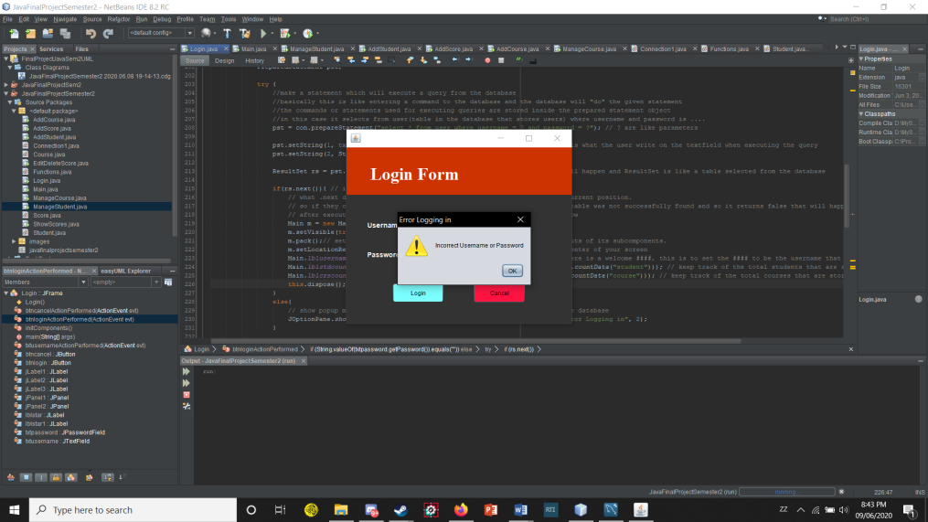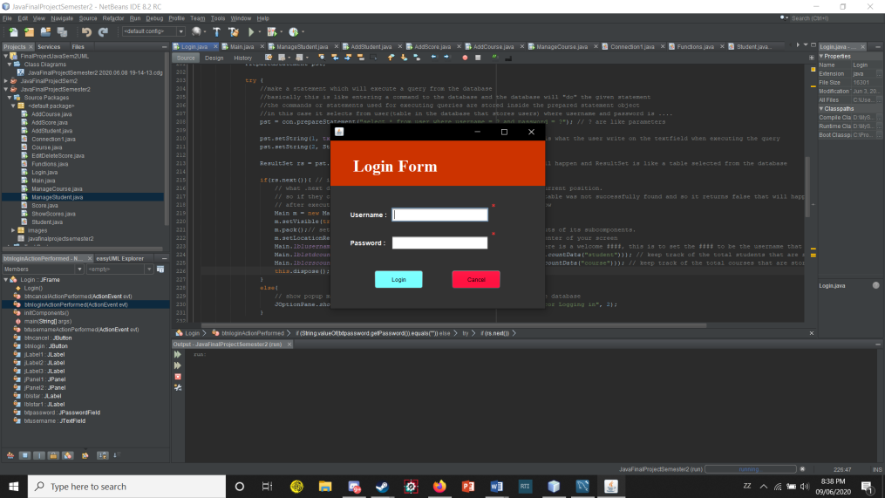

The Main window is basically our main menu in the system. The welcome #### text checks the username we entered and fill the #### with the given username. There are also two other boxes which includes texts inside. The left one is to indicate how many students we have registered, and the right one is to indicate how many courses there are in the system.

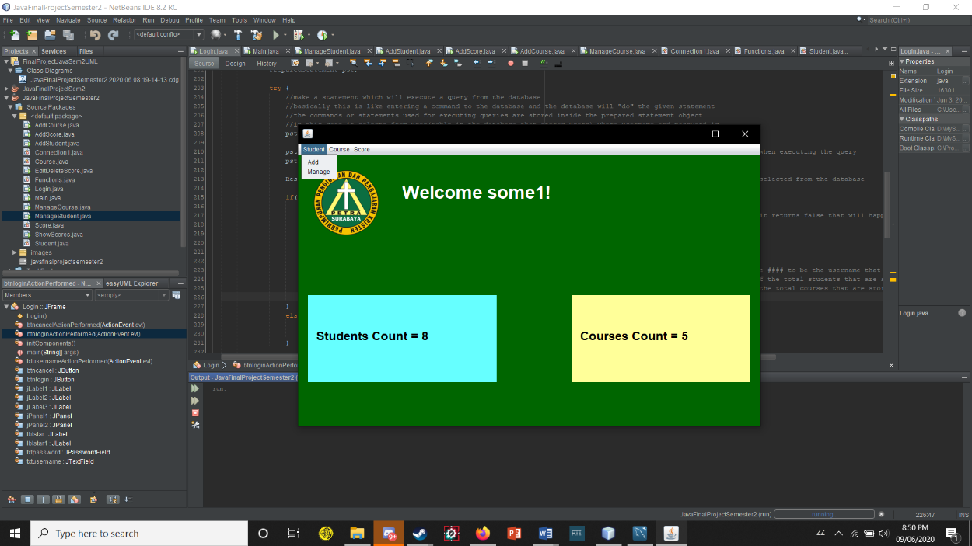

If we look at the menus at the top of the window, we will see 3 options we can select, Student, Course, Score. The Student and Course menus have add and manage menu items, while the Score menu has Add, Edit/Delete, ShowScores.

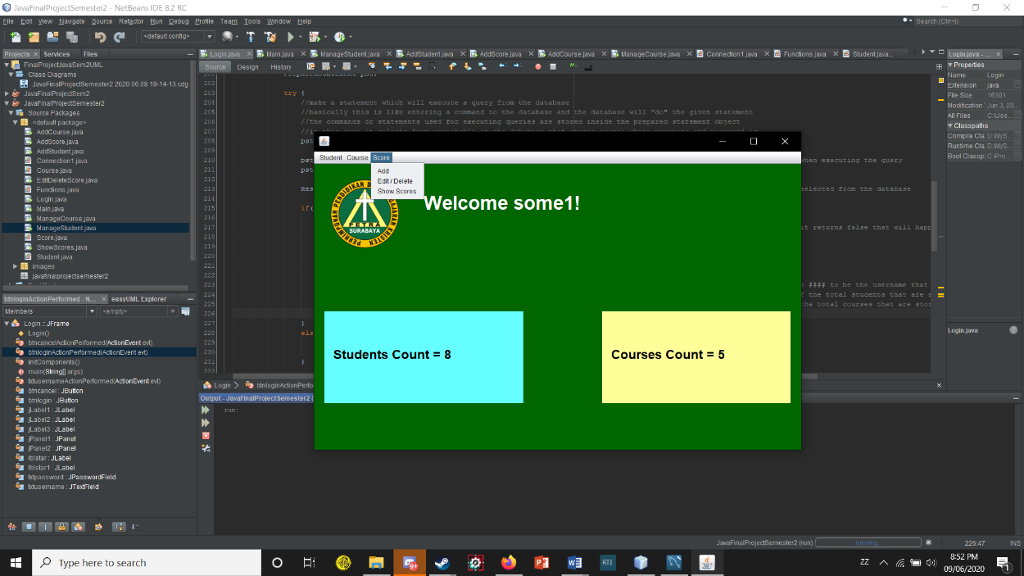

Clicking on the Add Student menu item, a new form/window will appear for us to fill in the form in order to add Students and their data to the database with the data being First Name, Last Name, Gender, Birthdate, Phone, Address. If one or more fields are blank when we press the add button, it will pop out a message to remind us to fill in all of the fields.

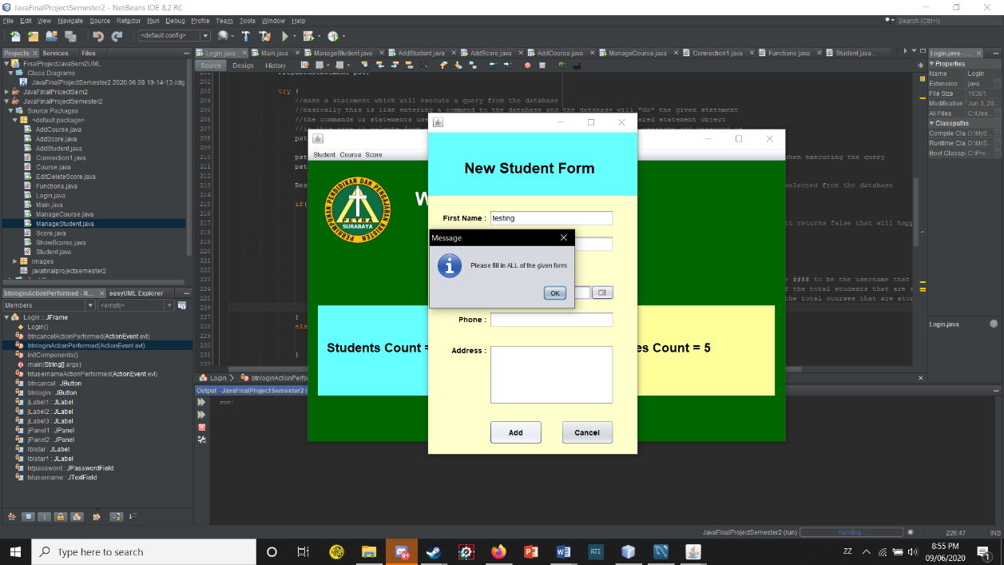

If we fill in all the forms, and press the add button, a message will pop out saying “New Student Added” indicating that the student data have successfully been stored into the database. The Students Count will also change because we added a new student so it counts how much students are in the database and shows it in the text on the main menu.

To close the add student form, we can just click on the cancel button or the close button to dispose the window.

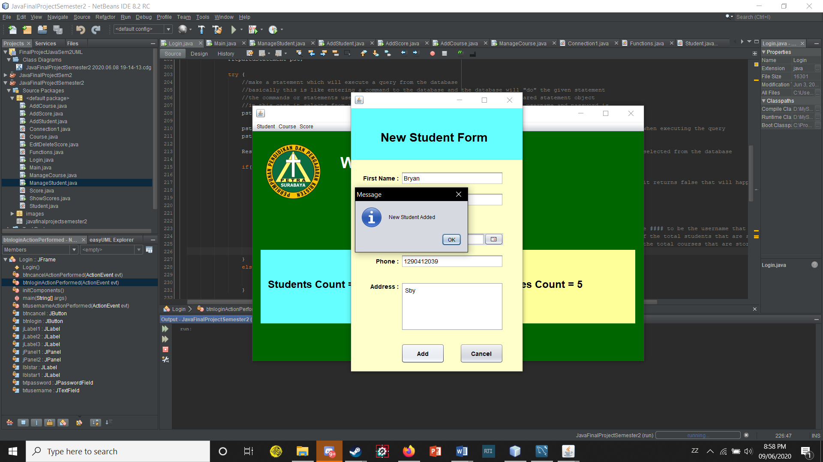

Then there is the Manage menu item on the Student menu. If we click it, an another new window will pop out which is the manage students window. The window has a table which contains the data of all students that are added in to the database for us to edit or manage it. We can also add students in the window by clicking on the add button which basically does the same thing as the menu item add on the students menu.

We can also search from the table by typing the data that we want to search. But I made it so that we can only search using the First Name, Last Name, Phone, Address to make it easier for people to search through. So if we search using the birthdate or gender, it doesn’t do anything.

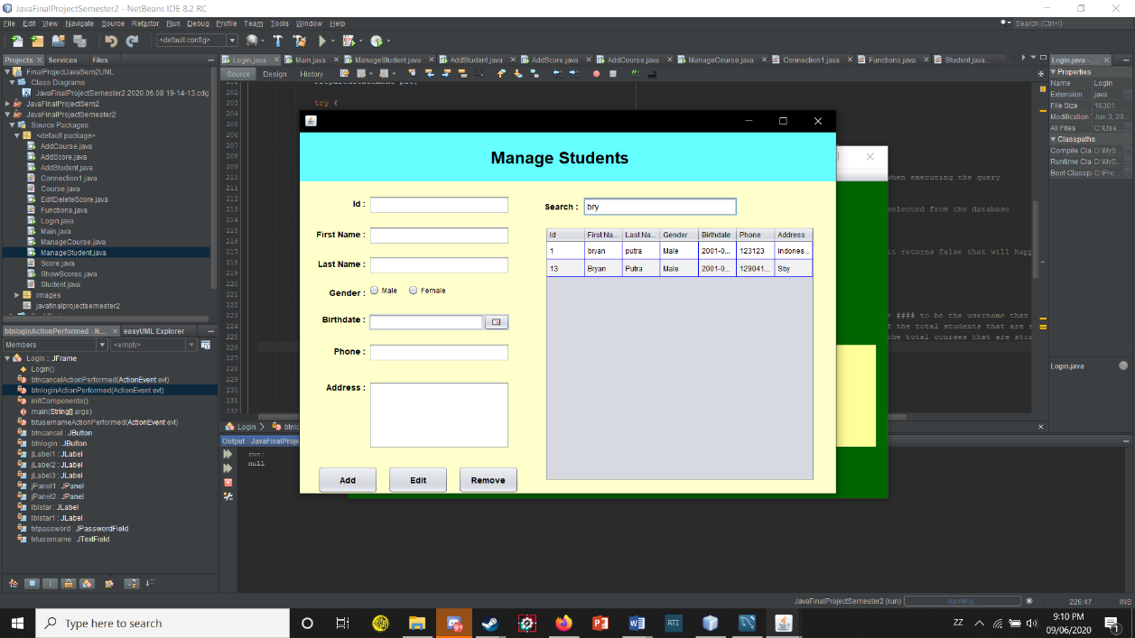

If we select a data from the table, the forms will automatically fill itself according to the data that we selected. If we want to just edit it, we can just change the data in the forms after selecting a row in the table. After changing, we can press the edit button to actually edit the data so that the database can be updated. The table will also be updated after clicking ok on the message window.

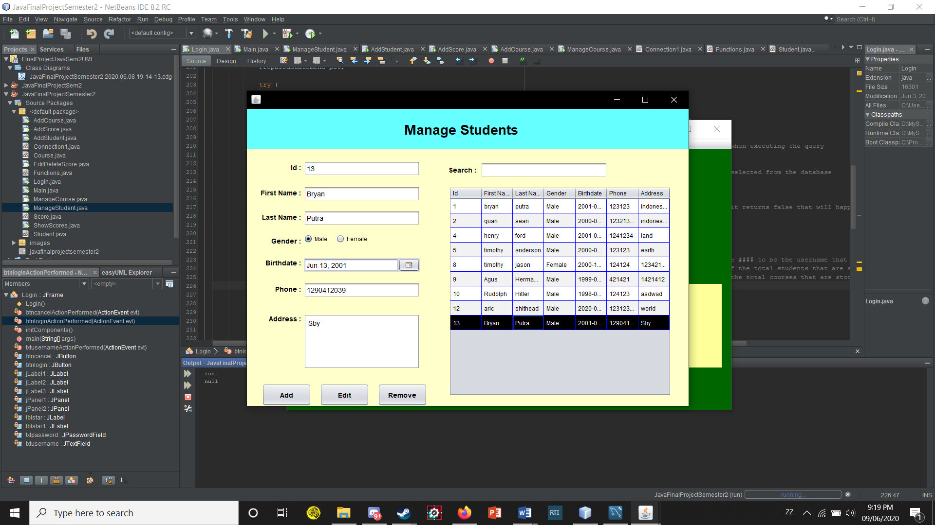

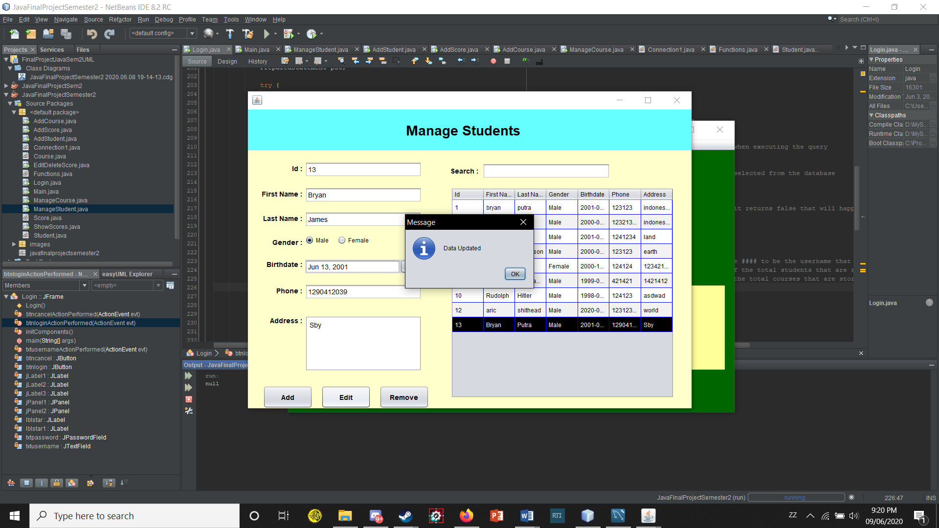

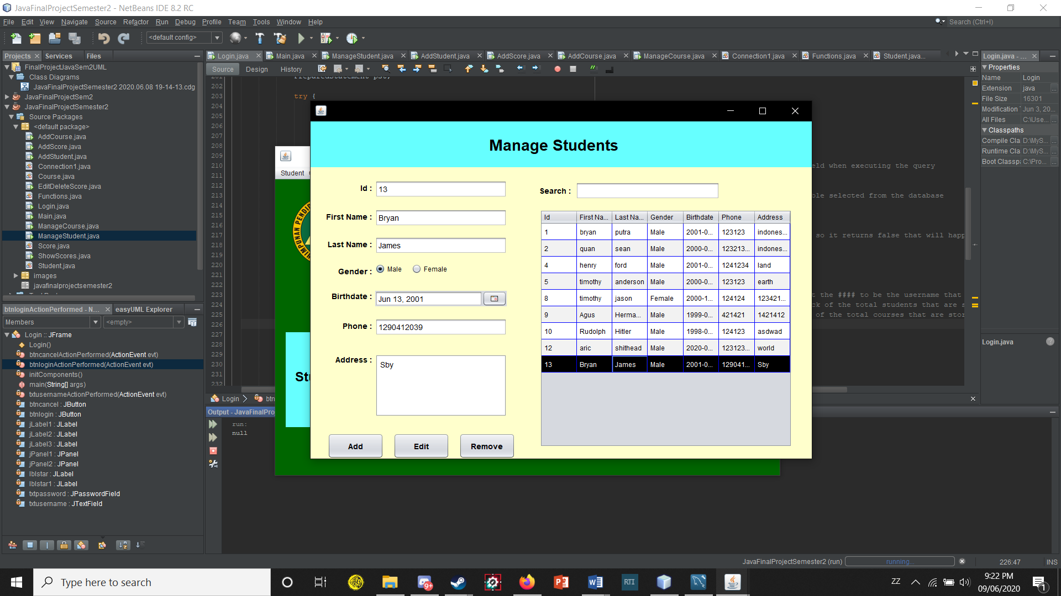

There is one other button we haven’t mention which is the remove button. The remove button allows us to remove a selected data. So if we select a certain data then click on the remove button, it will give us a warning first. The warning contains the message “Deleting a student data will also delete their scores, are you sure you want to continue?”

If we press ok then we deleting a student will also delete his or her scores and also pops out a message student data deleted. After pressing ok, the student table will also be updated after we remove a student.

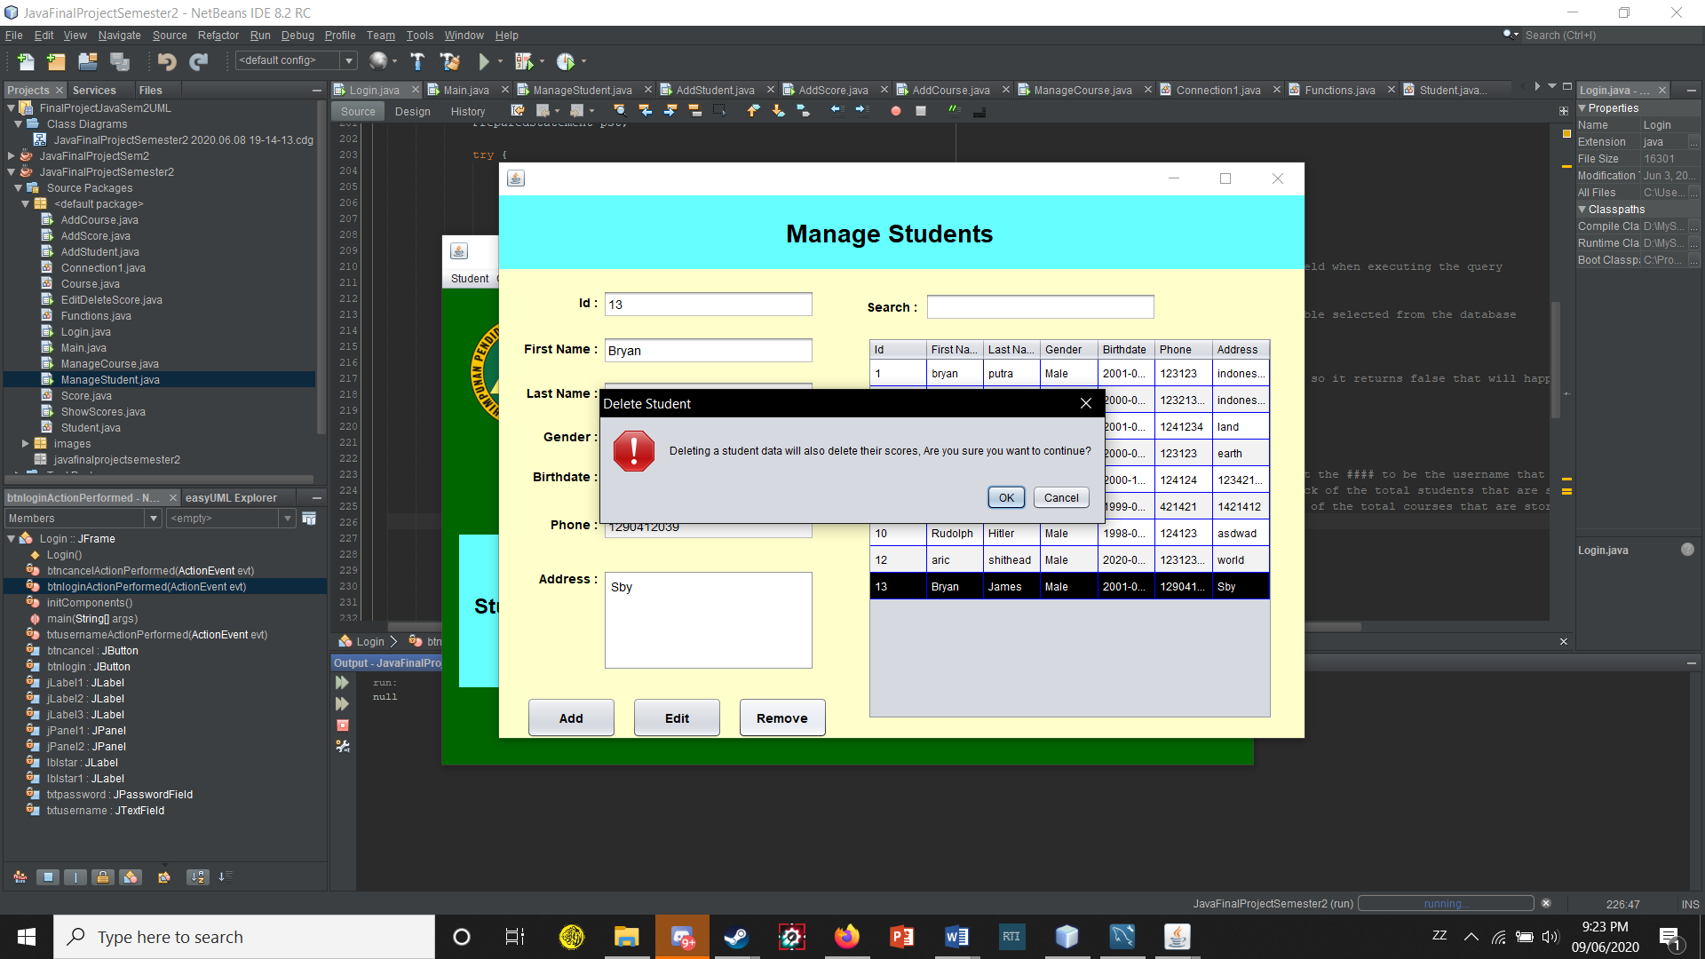

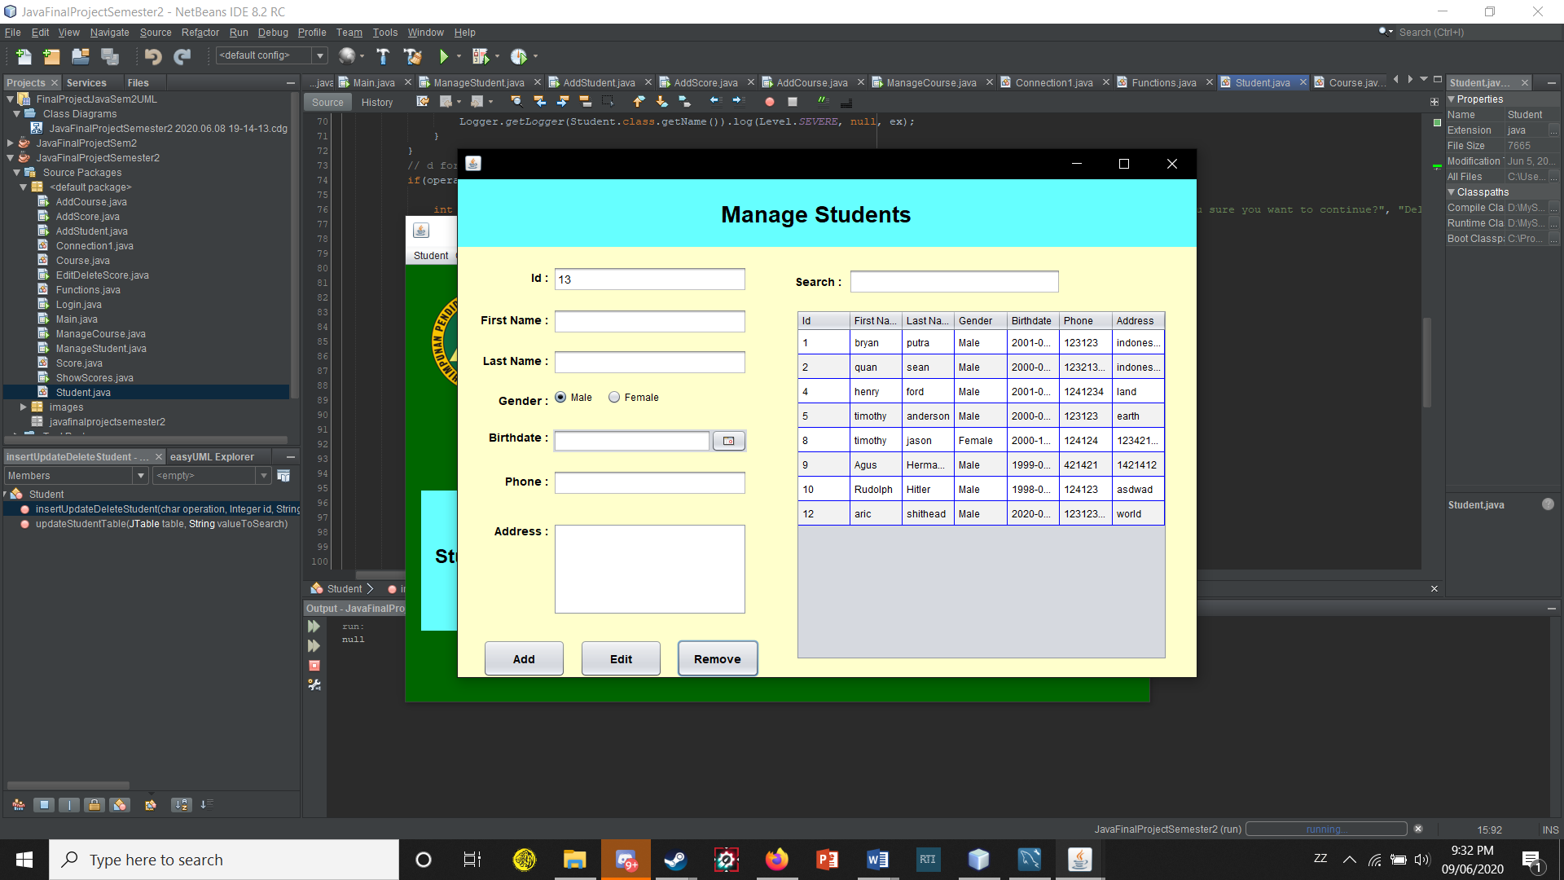

On the 2nd menu which is the Course menu, if we click on the add, a window will pop out for us to fill what course we want to add, and how many hours each course will have. Clicking on the add button after filling in the forms will add a new course given by the user to the database. Also if we add a course which already exists in the database, for instance, in the database there is already a course named JavaScript, we can’t add a new course named the same as the course JavaScript, so we must add a different course.

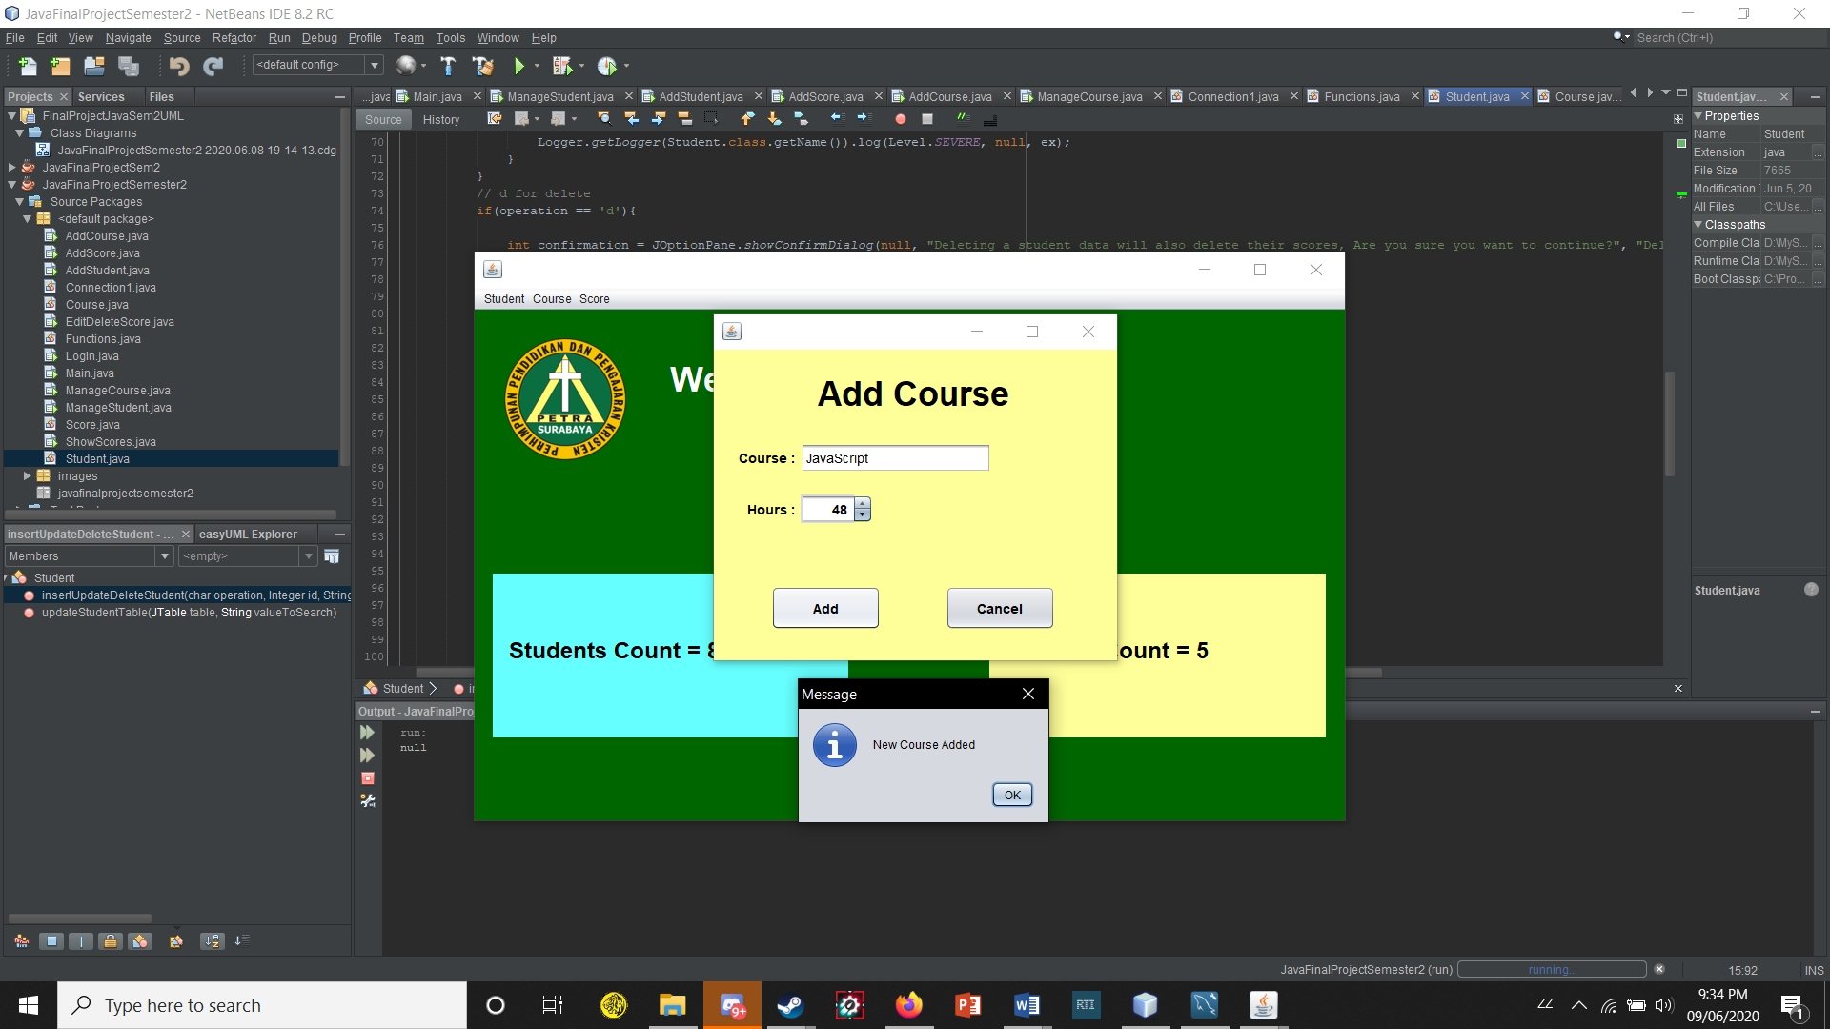

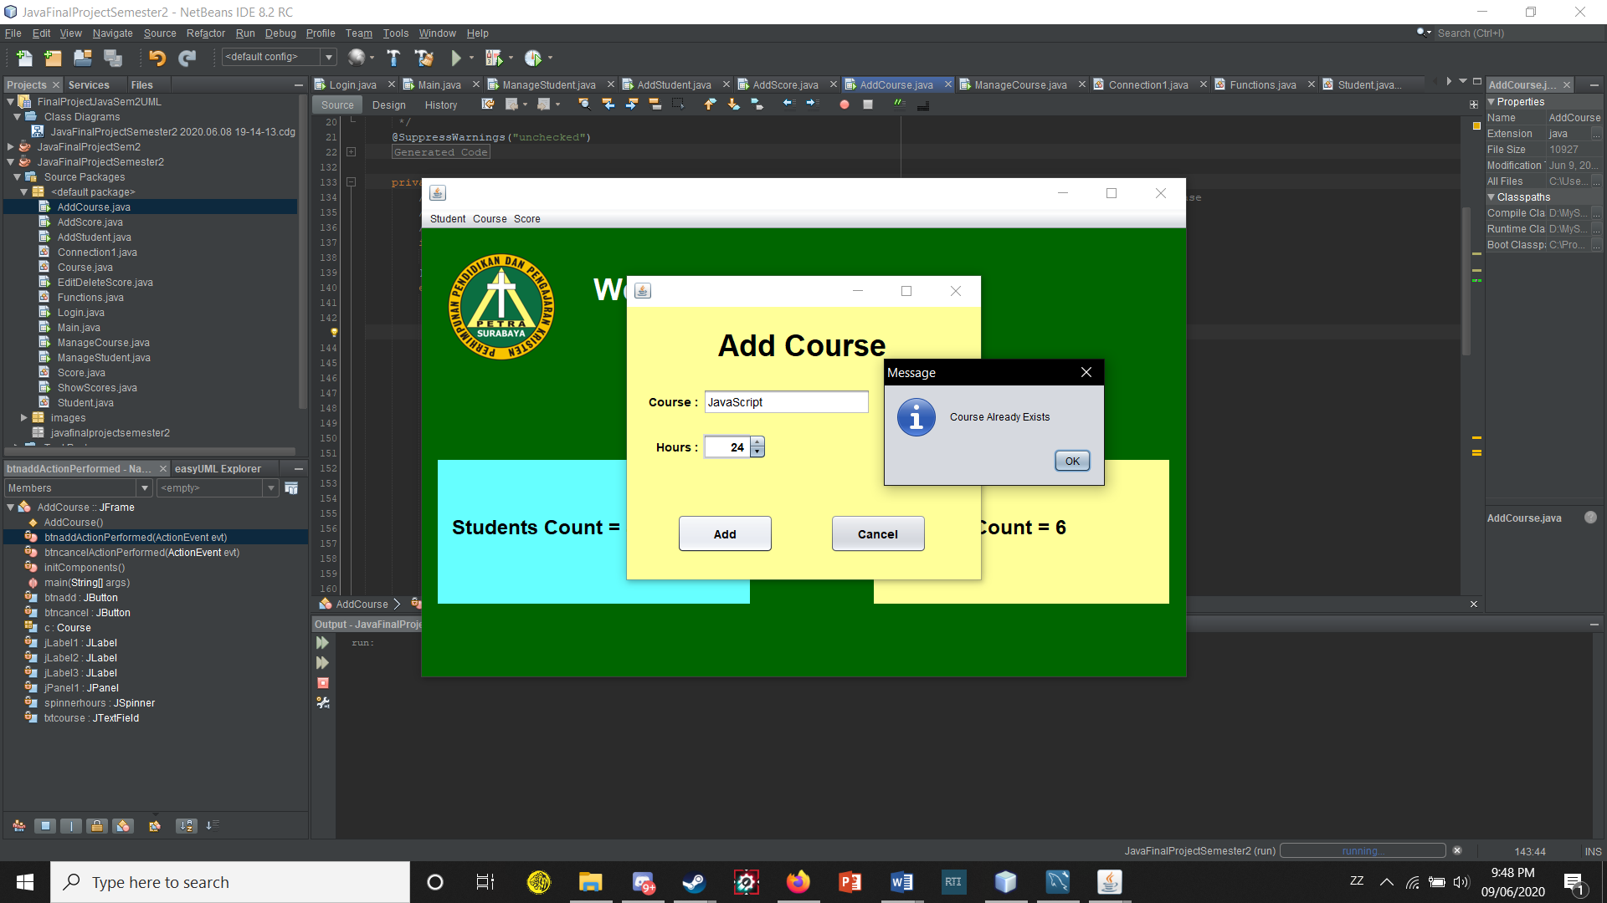

The manage menu item in the course menu will basically do the same thing with the manage student form, just different data and there is no search feature. How it works is also very similar with the buttons and the selecting row/data on the table.

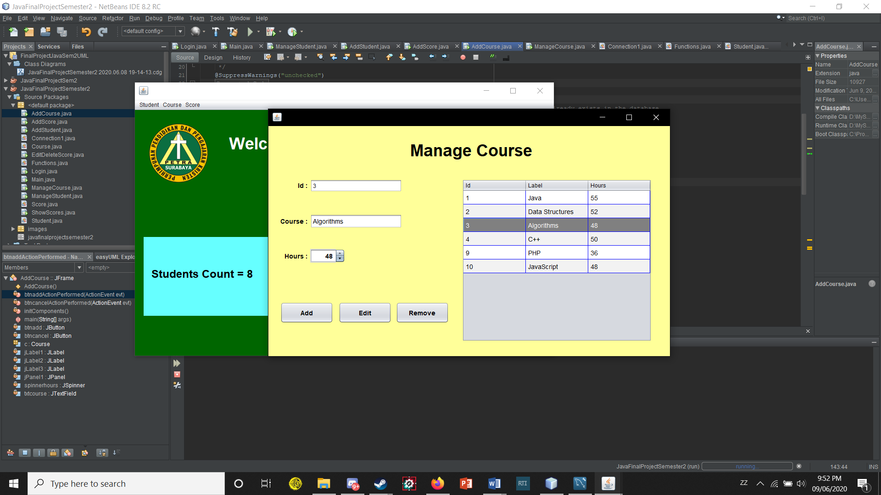

The last menu is the Score menu. Opening the add menu item on the score menu will make a new window appear which is the window for adding scores. In the window, there is a table that contains students that we want to give scores to. So first when we want to add a score we must select a student first, selecting a student will fill the student id field which selects the student id we want to give a score to. After entering a course and the score and the description(can be anything but I recommend writing what kind of test it is, like final exam or something to note) click the button add to add the data given to the database.

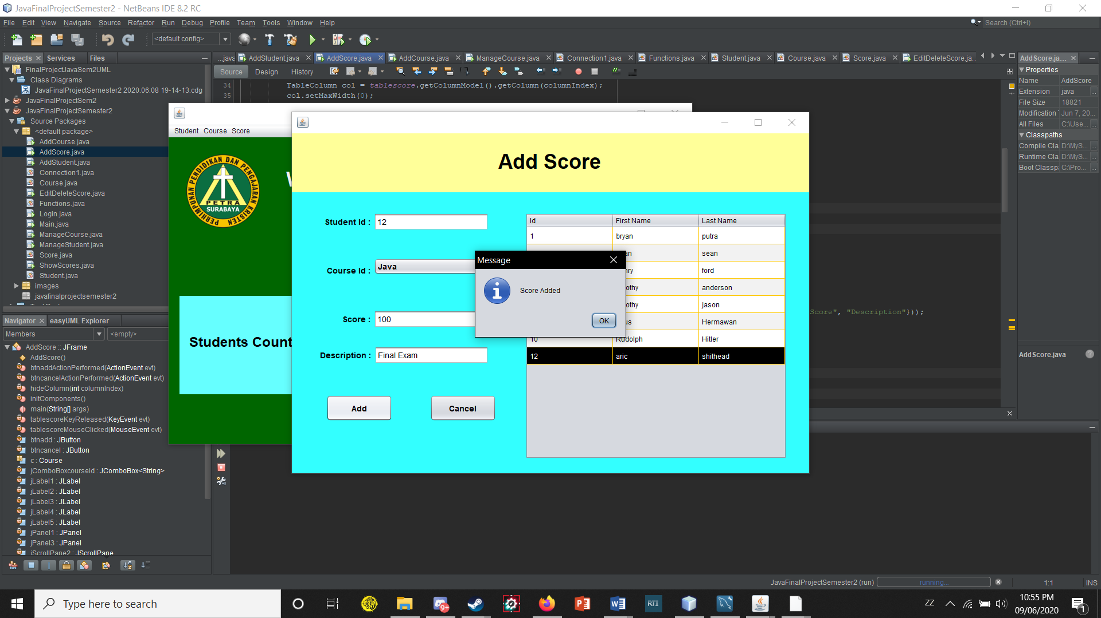

The next menu item is the Edit/Delete. Basically how it works is really similar to the other 2 manage menus, we select one of the rows/data in the table and edit it from the form, but the course id and student id cannot be edited because it would just cause chaos. So we just edit the score and description that the student has on a certain course.

The table will also be updated upon editing the data. How the button add and remove is also the same as the other menus(clicking on the button add will pop out the add score form that I just explained in the above text.)

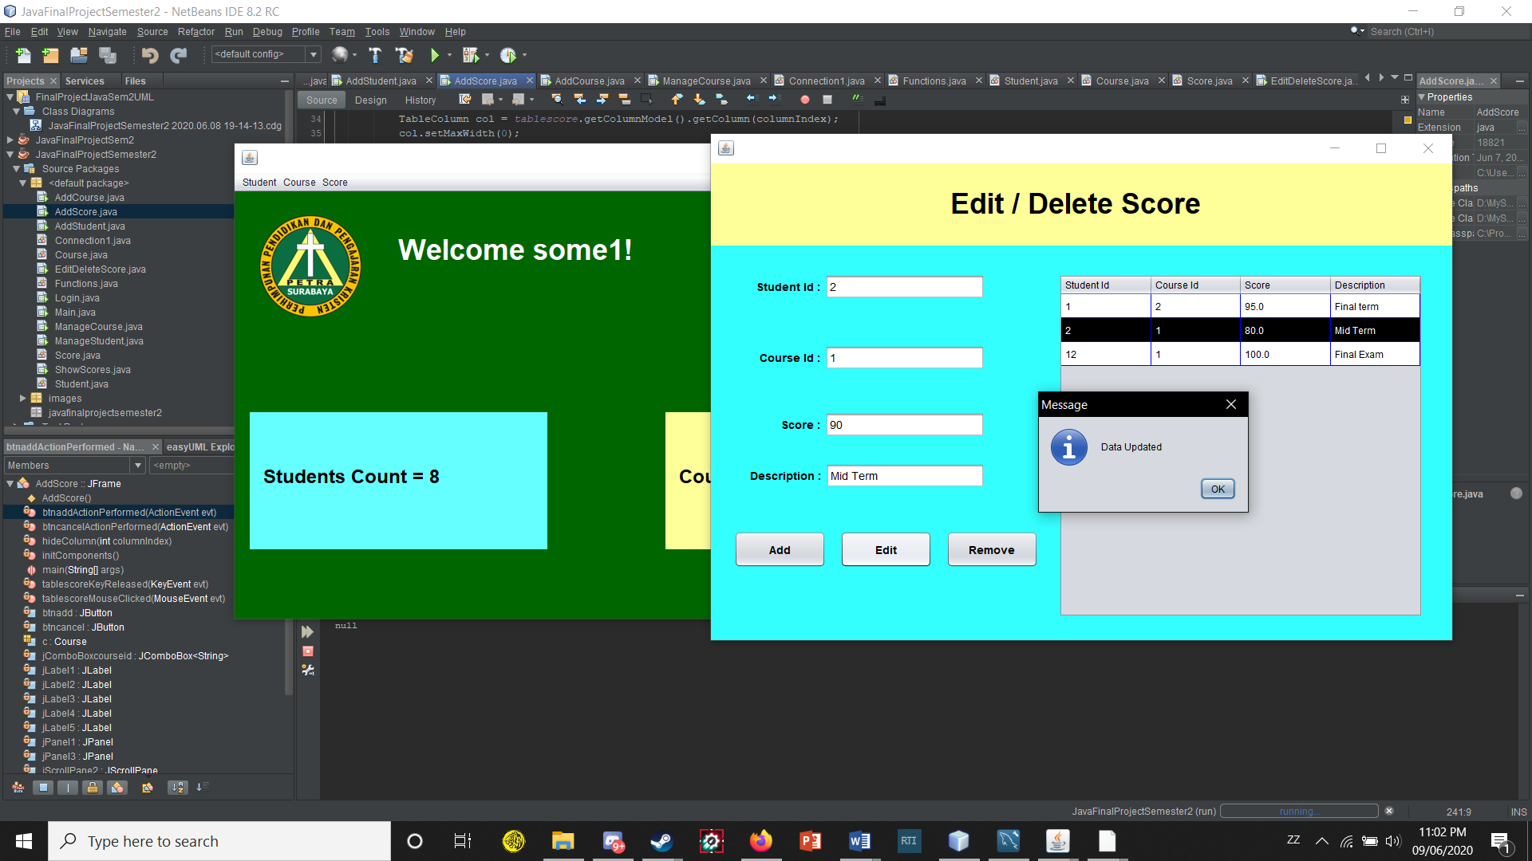

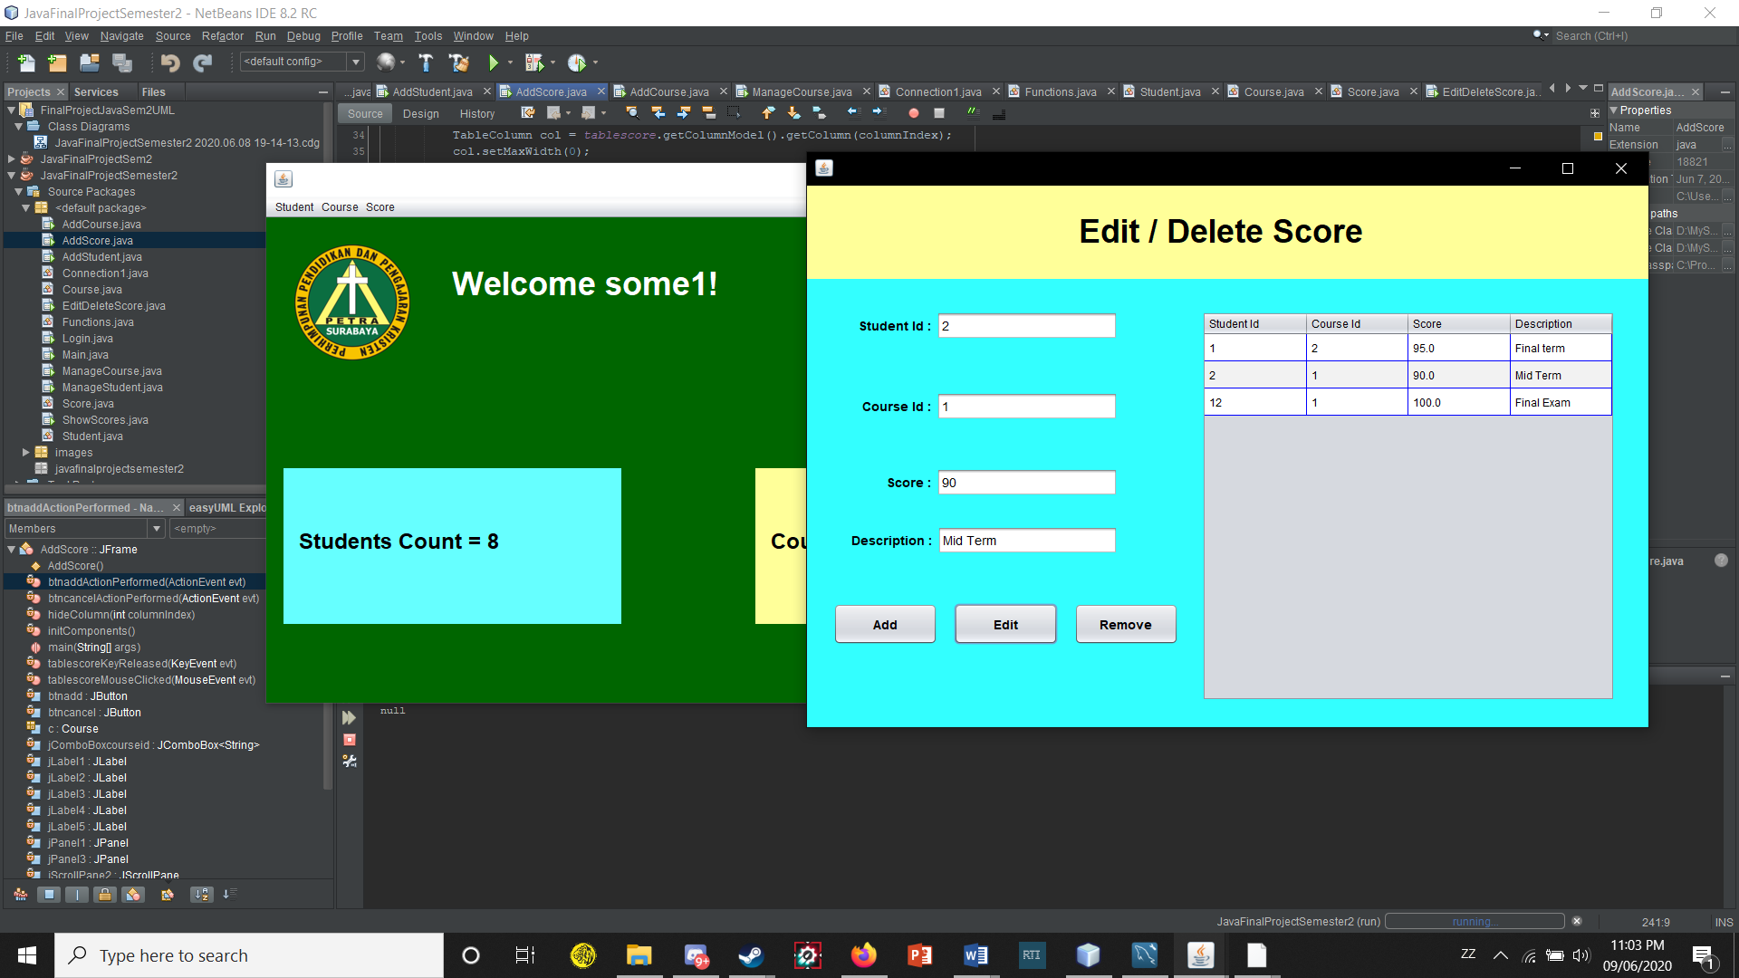

The last menu item which is ShowScores basically does what the title menu item says. It shows all the scores recorded in the database with student and course identifier so it is easier to read.

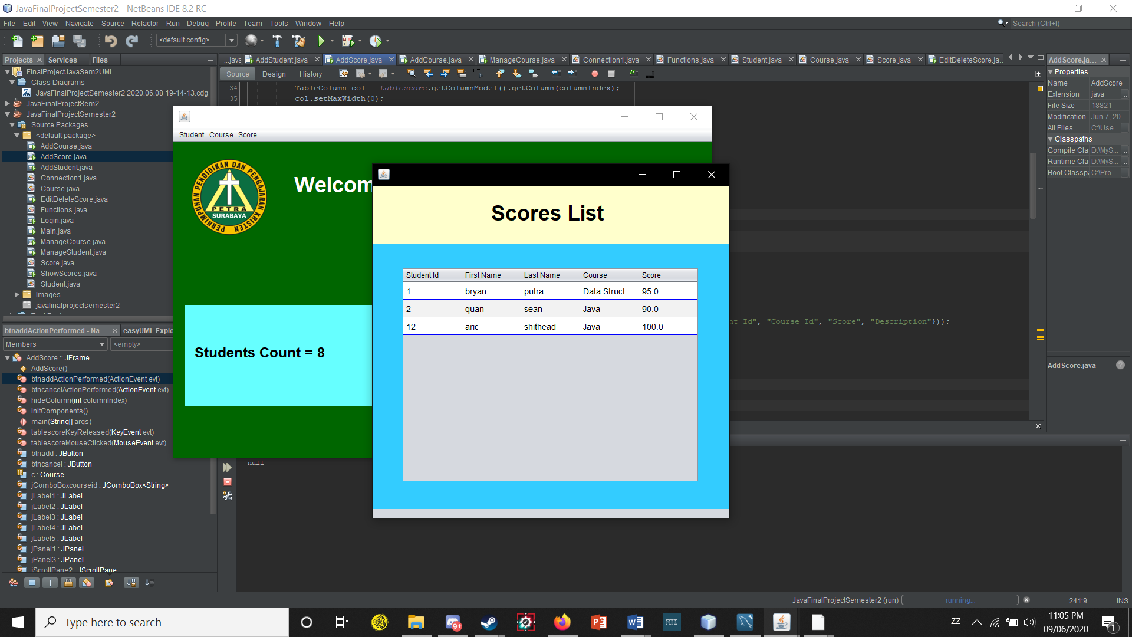

That’s pretty everything, also to close the program just click on the x in the main window(our main menu).

These are the tables in my database using the MySQL Workbench.

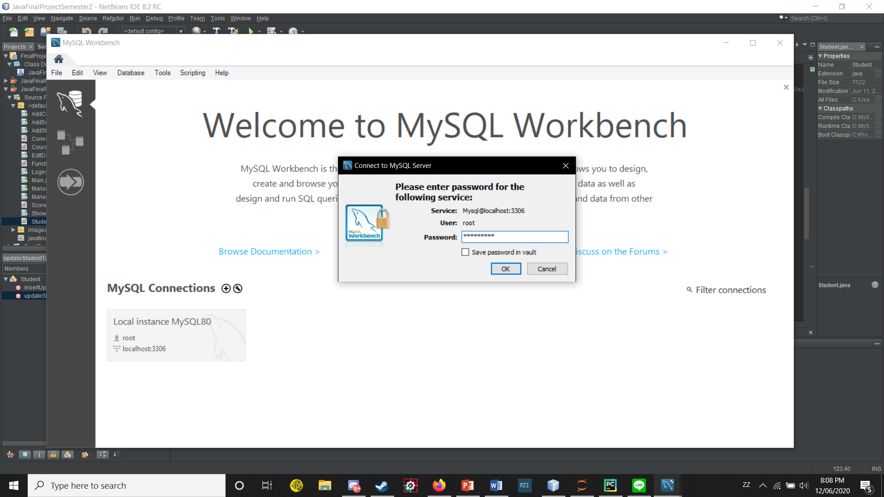

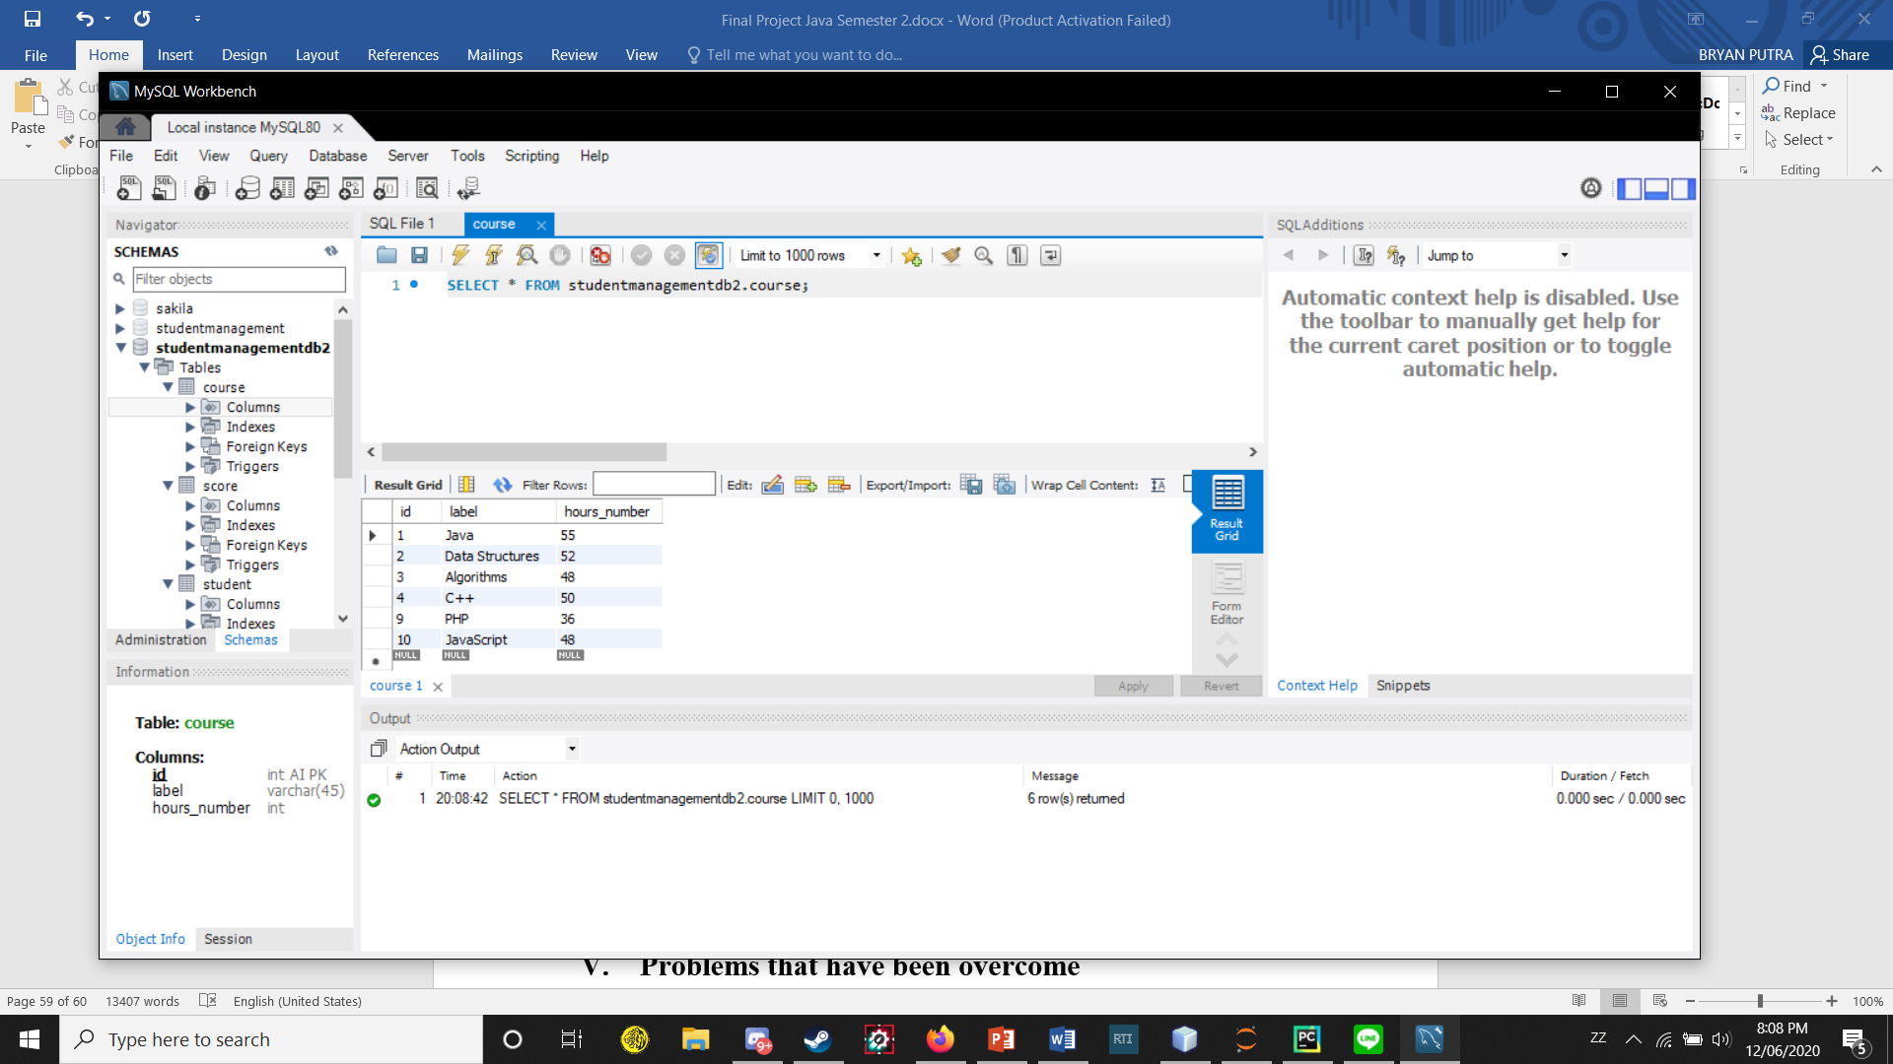

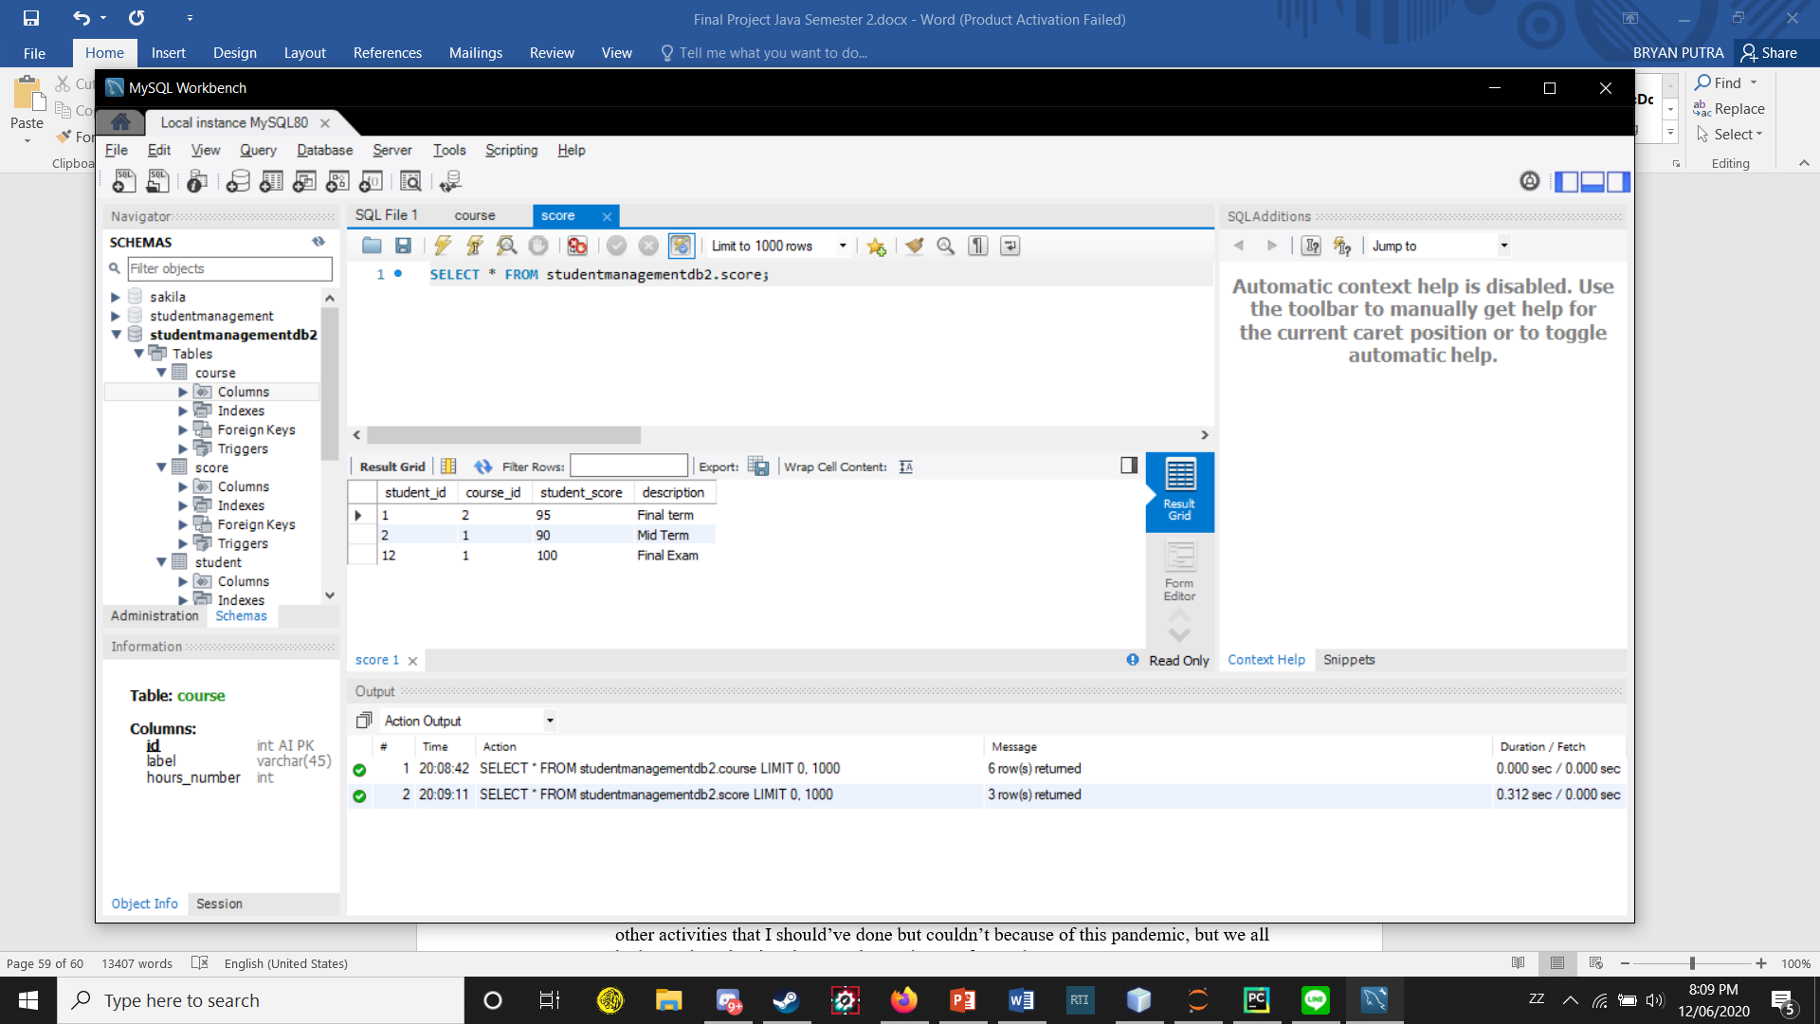

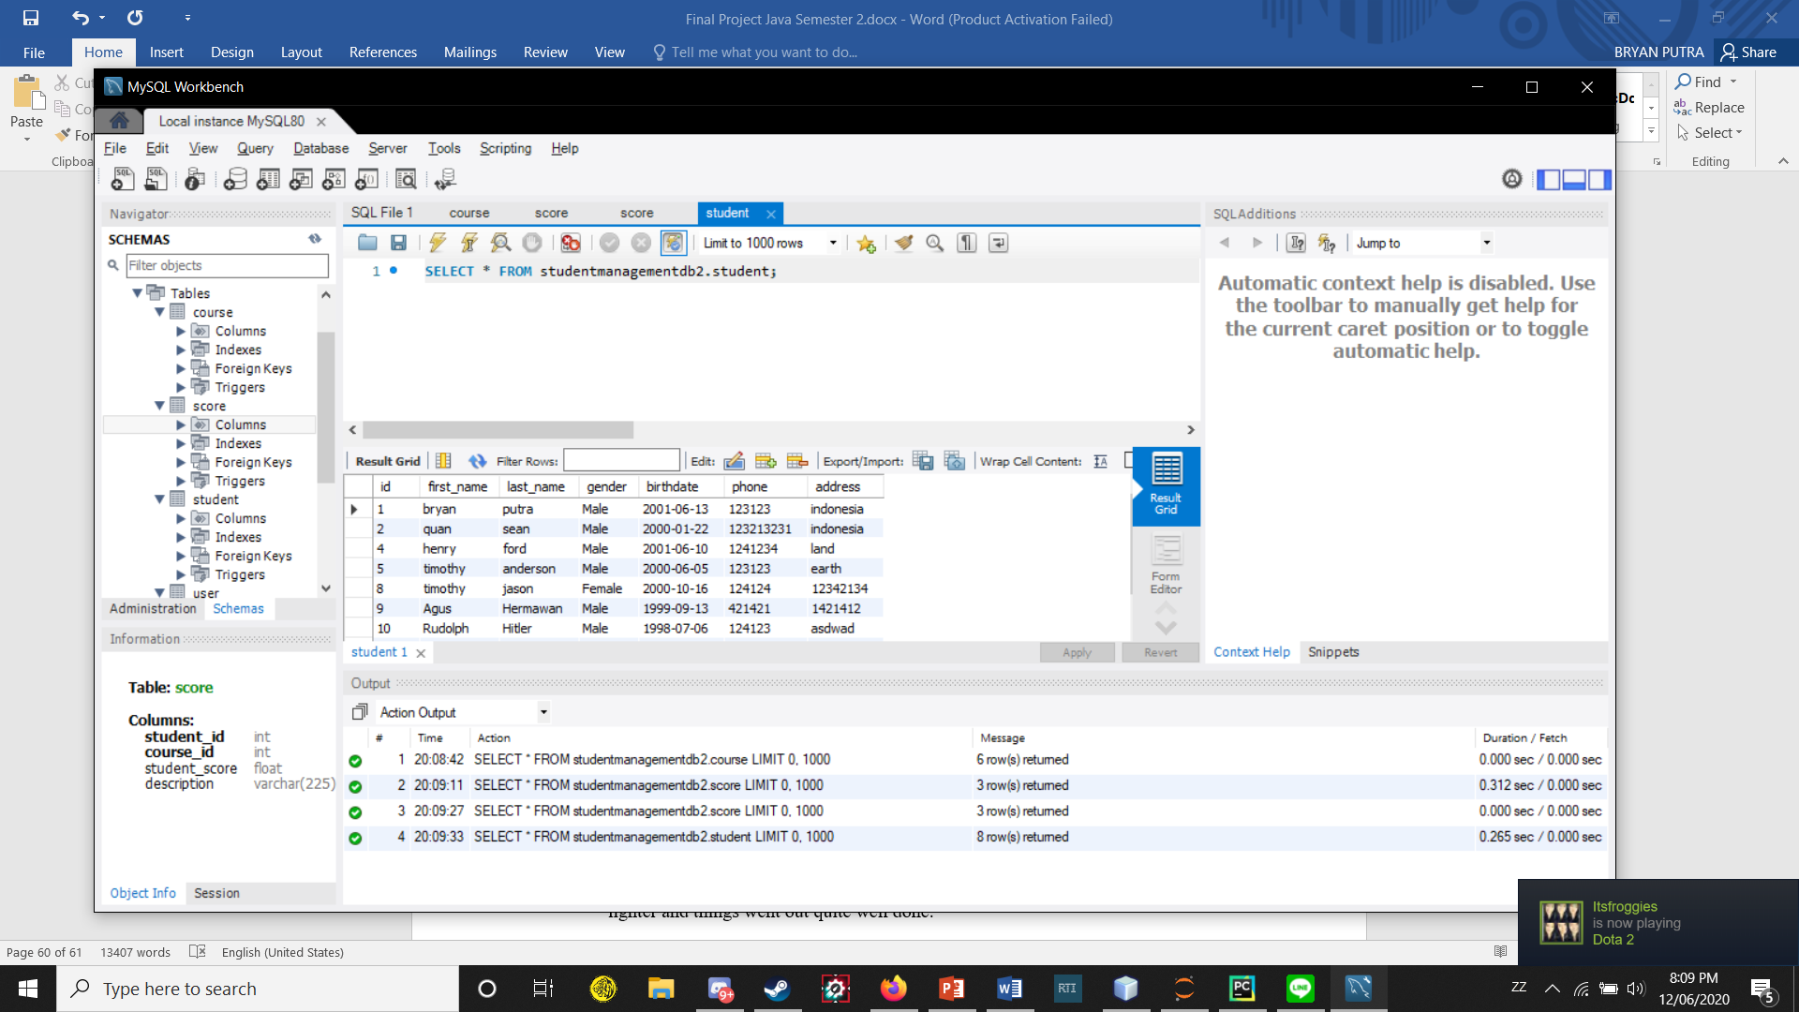



1. **Problems that have been overcome**

At first I didn’t really know what to make with Java because I’m not really that creative of a person, so I just searched some simple ideas for a project that I know I can learn something new from doing it. Then I came across an idea which is a student management system using a database called MySql. I had no idea what or how that thing works so early on not knowing much, I struggled learning it and I also had less motivation because at the time I was doing this project, we were still studying at home because of the coronavirus pandemic. I felt like I had a huge amount of decreasing productivity in my daily life because of the pandemic and it affected my studies and other activities that I should’ve done but couldn’t because of this pandemic, but we all had to endure the situation together and move forward.

I guess the hard part was just the learning from start, as soon as I understood most of the concepts and the implementation and actually finishing it, things started to feel like lighter and things went out quite well done.

1. **Resources**

<https://www.youtube.com/watch?v=F4vpJJH2PZU> to know the basics of how to build the project that I wanna make

<https://www.youtube.com/watch?v=7S_tz1z_5bA&t=467s> to study about MySql which I used for this project for the database

The rest is just a lot of googling

1. **Source Code**

<https://github.com/BryanPutra/FinalProjectJava2ndSemester>